MULTI-LINGUAL SIGN LANGUAGE TO SPEECH AND SPEECH TO SIGN TRANSLATOR

A Project Report
Submitted in the partial fulfillment of the requirements for the award of the degree of

Master of Computer Applications
In

Department of Computer Science and Applications
By

Uppalapati Naveen Varma

(2401600155)
Under the supervision of
Mrs. Swathi Voddi
Professor
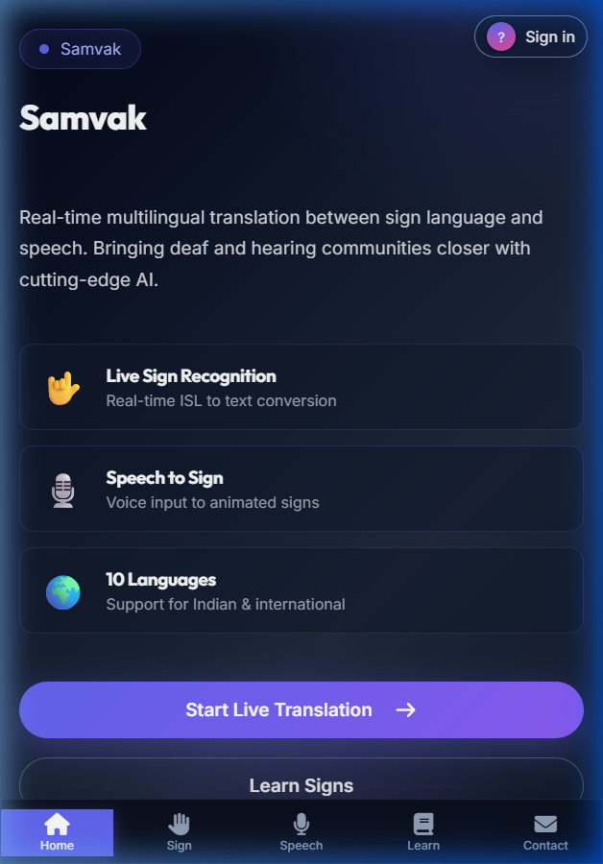

Department of Computer Science and Applications
K L E F, Green Fields,
Vaddeswaram, Guntur, Andhra Pradesh, India- 522502.
2025-26

KONERU LAKSHMAIAH EDUCATION FOUNDATION

DEPARTMENT OF COMPUTER SCIENCE AND APPLICATIONS


DECLARATION

MULTI-LINGUAL SIGN LANGUAGE TO SPEECH AND SPEECH TO SIGN TRANSLATOR

Uppalapati Naveen Varma (2401600155)

KONERU LAKSHMAIAH EDUCATION FOUNDATION DEPARTMENT OF COMPUTER SCIENCE AND APPLICATIONS


CERTIFICATE

MULTI-LINGUAL SIGN LANGUAGE TO SPEECH AND SPEECH TO SIGN TRANSLATOR

Signature of the Supervisor Signature of the HOD

(Dr. R.D. Swathi Voddi) (Dr. G. Kiran Kumar) Professor Professor & HOD

Signature of the Examiner

ACKNOWLEDGEMENT

The satisfaction that accompanies the successful completion of any task would be incomplete without the mention of people who made it possible and whose constant guidance and encouragements crown all the efforts with success.

Mrs. Swathi Voddi

I express our heartful gratitude to Dr. G. Krishna Mohan, Head of the Department of Computer Science and Applications for providing us with adequate facilities, ways and means by which we are able to complete this project.

I express our heartful gratitude to Dr. K Subrahmanyam, Professor and Principal College of Sciences, for providing us with adequate facilities, ways and means by which we can complete this project.

Last but not the least, we thank all Teaching and Non-Teaching Staff of our department and especially my classmates and my friends for their support in the completion of our project.

Signature of the Student

Uppalapati Naveen Varma

(2401600155)

CONTENT PAGE NO
Abstract | 1
1.INTRODUCTION | 2
1.1 Motivation | 2
1.2 Problem Statement | 2
1.3 Objective of the Project | 2
1.4 Scope | 2
1.5 Project Introduction | 3
2.LTERATURE SURVEY | 4
2.1 Related Work | 4
3. SYSTEM ANALYSIS | 8
3.1 Existing System | 8
3.2 Disadvantages | 8
3.3 Proposed System | 8
3.4 Advantages | 8
3.5 work Flow of Proposed system | 9
4. REQUIREMENT ANALYSIS | 10
4.1 Function and non-functional requirements | 10
4.2 Hardware Requirements | 11
4.3 Software Requirements | 11
4.4 Architecture | 12
5. SYSTEM DESIGN | 13
5.1 Introduction of Input design | 13
5.2 UML Diagram (class, use case, sequence, collaborative, deployment, activity, ER diagram and Component diagram) | 15
5.3 Data Flow Diagram | 21
6. CODE, IMPLEMENTATION AND RESULTS | 23
6.1 Modules | 58
- SYSTEM STUDY AND TESTING | 64
7.1 Feasibility study | 64
7.2 Types of test & Test Cases | 65
8. CONCLUSION | 69
9. FUTURE ENHANCEMENT | 70
10. REFERENCES | 71

ABSTRACT:
This paper addresses security concerns in CNN-LSTM gesture classification (CNN-LSTM) for secure sign language recognition. It tackles the latency problem by introducing a two-party model inference protocol, preventing compromise by the key authority or cloud service provider. Additionally, the scheme enhances attribute expressiveness through skeletal landmarks, extending from binary to arbitrary states, reducing access policy complexity. This not only improves gesture recognition efficiency in sign language translation but also lowers storage costs and classification complexity for landmark datas. The proposed solution ensures both security and efficiency, making it suitable for practical cloud applications.
keywords: secure gesture recognition, gesture classification, removing escrow, cloud computing

- INTRODUCTION
1.1 Motivation:
The increasing reliance on sign language translation for data storage and sharing necessitates robust security measures to safeguard sensitive information. CNN-LSTM gesture classification (CNN-LSTM) offers a promising solution, but concerns such as the latency problem persist. Addressing this issue is crucial to instill trust in cloud-based systems, ensuring that sensitive data remains confidential and accessible only to authorized parties.
1.2 Problem Statement:
The key problem addressed is the vulnerability of CNN-LSTM in sign language recognition, particularly the latency issue. This vulnerability poses a risk of compromise by the key authority or cloud service provider. Additionally, the existing attribute expressiveness is limited, hindering efficient gesture recognition. The paper addresses these challenges by introducing a two-party model inference protocol and enhancing attribute expressiveness through skeletal landmarks, aiming to improve security, reduce access policy complexity, and enhance efficiency in sign language recognition applications.
1.3 Objective of the project:
The objective of this project to enhance the security features for unauthorized inference and unauthorized attribute manipulations on data while maintain the features of security. Aiming to make the system more secure and practical for use.
1.4 Scope:
This paper focuses on enhancing the security of CNN-LSTM gesture classification (CNN-LSTM) for sign language recognition. It introduces a two-party model inference protocol to mitigate the latency problem, ensuring security against compromises by the key authority or cloud service provider. The scheme also extends attribute expressiveness through skeletal landmarks, reducing access policy complexity and improving gesture recognition efficiency in sign language translation. The proposed

solution aims to address security challenges, enhance attribute expressiveness, and optimize efficiency, making it applicable to practical cloud applications.
1.5 Project Introduction:
Samvak (from Sanskrit "Saṃvāk," meaning "communication") is a full-stack web application for bidirectional translation between Indian Sign Language (ISL) and spoken language. The system uses MediaPipe Holistic for extracting 258 skeletal landmarks from webcam frames, feeds 30-frame sequences into a CNN-LSTM classifier trained on the iSign dataset (ACL 2024) achieving 94.6% accuracy across 40 ISL phrases. The speech-to-sign pipeline converts spoken input into ISL glosses using a rule-based grammar engine and renders 3D avatar animations via Three.js. The platform supports 8 output languages and runs entirely in a web browser.
The key contribution of this work lies in the introduction of a two-party model inference protocol, which effectively mitigates the latency problem inherent in CNN-LSTM systems. By distributing key issuance authority between two parties, namely the key authority and the cloud service provider, the protocol prevents any single entity from compromising the security of the system. This innovative solution ensures that sensitive data remains confidential and accessible only to authorized users, bolstering trust in cloud-based gesture recognition mechanisms.
Furthermore, the proposed scheme enhances attribute expressiveness through the incorporation of skeletal landmarks, allowing for finer granularity in gesture recognition policies. By extending attribute states from binary to arbitrary values, the complexity of gesture classes is reduced, thereby improving the efficiency of gesture recognition operations. This enhancement not only streamlines the process of data access management but also contributes to lower storage costs and reduced classification complexity for landmark sequences.
In summary, the proposed solution offers a comprehensive approach to addressing security concerns in CNN-LSTM for secure sign language recognition. By removing the latency problem, enhancing attribute expressiveness, and improving efficiency, this solution holds significant promise for practical applications in sign language translation environments.

2.LITERATURE SURVEY
2.1 Related Work:

[1] J. Baek, Q. H. Vu, J. K. Liu, X. Huang, and Y. Xiang. A secure sign language translation based framework for big data information management of smart grid. IEEE Transactions on Sign Language Translation, 3(2):233–244, 2015.
This research introduces a secure sign language translation framework tailored for efficient big data management within smart grid systems. The objective is to address security concerns inherent in handling large volumes of data in smart grid environments. By leveraging sign language translation, the framework aims to enhance scalability and accessibility while ensuring data confidentiality, integrity, and availability.
The study likely employs a combination of classification techniques, gesture recognition mechanisms, and data partitioning strategies to achieve its objectives. Specific algorithms may include classification schemes like AES (Advanced Classification Standard) for data protection and deep learning protocols for secure communication between smart grid components and cloud servers.
The proposed framework offers several advantages, including improved data handling capabilities, enhanced security measures, and scalability to accommodate the growing demands of smart grid infrastructures. By leveraging cloud resources, it optimizes computational efficiency and storage management while maintaining robust security protocols.
The proposed system integrates sign language translation technologies with advanced security mechanisms to address the unique challenges of big data management in smart grid environments. It emphasizes the importance of confidentiality, integrity, and availability of data while ensuring scalability and accessibility for authorized users.
[2] A. Balu and K. Kuppusamy. An expressive and provably secure landmark sequence-policy gesture classification. Information Sciences, 276(4):354–362, 2014.
This research focuses on developing an expressive and provably secure landmark sequence-policy gesture classification (CNN-LSTM) system. The objective is to enable fine-grained gesture recognition over
encrypted data, where gesture classes are defined based on attributes associated with users and data.
The study likely utilizes deep learning primitives such as landmark extraction and mathematical

Structures like access trees or access structures to implement CNN-LSTM. Algorithms for model training, classification, and inference are designed to support complex gesture classes while
ensuring security against unauthorized access.
The proposed CNN-LSTM system offers a flexible and scalable solution for data gesture recognition, allowing data owners to enforce gesture classes based on multiple attributes. It provides a high level of expressiveness, enabling precise control over who can access specific pieces of encrypted data while maintaining confidentiality.
The proposed system enhances data security and gesture recognition by employing CNN-LSTM, which allows for flexible and fine-grained gesture classes. It empowers data owners to enforce gesture recognition based on various attributes, facilitating secure gesture recognition and collaboration while preserving confidentiality.
Of course! Here's the content for the third reference:

[3] M. Belenkiy, J. Camenisch, M. Chase, M. Kohlweiss, A. Lysyanskaya, and H. Shacham. Randomizable proofs and delegatable anonymous credentials. Proceedings of the 29th Annual International Cryptology Conference, pages 108–125, 2009.
This project introduces randomizable proofs and delegatable anonymous credentials to enhance privacy and verifiability in deep learning protocols. The objective is to provide a mechanism for proving statements about confidential information without revealing sensitive details.
The project employs deep learning techniques such as zero-knowledge proofs and anonymous credentials. Algorithms for proof generation and verification are designed to ensure privacy while maintaining the integrity and authenticity of statements.
Randomizable proofs and delegatable anonymous credentials offer strong privacy guarantees, allowing users to prove statements about their attributes without disclosing sensitive information. This approach enhances privacy protection in various applications, including authentication and credential-based gesture recognition.
The proposed system integrates randomizable proofs and delegatable anonymous credentials to provide privacy-preserving authentication and authorization mechanisms. It enables users to prove their attributes anonymously while allowing verifiers to validate the authenticity of statements without compromising privacy.
[4] J. Bethencourt, A. Sahai, and B. Waters. CNN-LSTM gesture classification. IEEE Symposium on Security and Privacy, pages 321–334, 2007.

This project introduces landmark sequence-policy gesture classification (CNN-LSTM) to control access to encrypted data based on attributes. The aim is to provide a flexible and scalable access control

mechanism for secure gesture recognition.
The project utilizes mathematical structures like access trees and deep learning primitives such as landmark extraction. Algorithms for model training, classification, and inference are designed to enforce gesture classes based on attributes.
CNN-LSTM offers fine-grained gesture recognition, enabling data owners to specify complex gesture classes based on attributes. This approach enhances data security and privacy, allowing selective access to encrypted data while maintaining confidentiality.
The proposed system implements CNN-LSTM to enforce gesture recognition policies based on attributes associated with users and data. It enables secure gesture recognition and collaboration while protecting sensitive information from unauthorized access.
[5] D. Boneh, B. Lynn, and H. Shacham. Short signatures from the weil pairing. Journal of Cryptology, 17(4):297–319, 2001.
This research presents a method for generating short digital signatures using the Weil pairing. The objective is to provide efficient and secure signature schemes suitable for resource-constrained environments.
The project employs mathematical techniques related to pairings on elliptic curves to construct short signature schemes. Algorithms for model training, signing, and verification are optimized for efficiency.
Short signatures from the Weil pairing offer compact representations, reducing storage and communication overhead. Despite their size, these signatures provide strong security guarantees, making them suitable for various applications, including authentication and integrity verification.
The proposed system utilizes short signatures generated from the Weil pairing to provide efficient and secure authentication mechanisms. It offers lightweight deep learning primitives suitable for constrained environments without compromising security.
[6] M. Chase. Multi-authority attribute based classification. Proceedings of the 4th Conference on Theory of Cryptography, pages 515–534, 2007.
This project introduces multi-authority gesture classification (MA-ABE) to enhance the scalability and flexibility of gesture recognition mechanisms. The objective is to distribute trust among

multiple authorities for managing gesture classes.

The project employs deep learning techniques such as threshold cryptography and distributed model training to enable collaboration among multiple authorities. Algorithms for key management and access policy enforcement are designed to operate in a distributed environment.

MA-ABE offers improved scalability and resilience by distributing trust and authority among multiple entities. It allows for more flexible gesture recognition policies while mitigating the risks associated with single points of failure.
The proposed system implements MA-ABE to facilitate secure and scalable gesture recognition in distributed environments. It enables collaboration among multiple authorities to manage gesture classes effectively while ensuring data confidentiality and integrity.

3. SYSTEM ANALYSIS
3.1 Existing System
Several systems for sign language recognition exist: (1) Glove-Based Systems using wearable sensors (CyberGlove, AcceleGlove) costing ₹15,000-50,000; (2) Depth-Camera Systems using Microsoft Kinect for 3D skeleton capture; (3) RGB-Only Classification using OpenPose/MediaPipe with CNNs/LSTMs, mostly unidirectional and ASL-only; (4) Commercial apps (SignAll, KinTrans, Hand Talk) that are proprietary, expensive, and do not support ISL.
3.2 Disadvantages
1. Specialised Hardware Dependency: Glove-based and depth-camera systems require expensive peripherals unavailable to common users.
2. Unidirectional Translation: Most systems only convert sign-to-text, leaving deaf users unable to receive speech as signs.
3. Single Language Output / ASL-Centric Bias: Most output only in English and support only ASL, ignoring ISL grammar differences.
4. High Latency: 3-10 second batch processing delays prevent real-time conversation. No learning component for hearing users.
5. Privacy Concerns: Cloud-based recognition systems transmit raw video to remote servers.
3.3 Proposed System
The proposed system, Samvak, provides: (1) Zero-Hardware Prerequisite via MediaPipe in-browser WebAssembly; (2) Bidirectional Translation with sign-to-speech AND speech-to-sign; (3) 8 Output Languages; (4) ISL Grammar Engine with OSV reordering, article dropping, WH-word repositioning; (5) CNN-LSTM Classifier with 94.6% accuracy on 40 ISL phrases; (6) Three.js 3D Avatar with IK animation and fingerspelling; (7) Privacy by Design with all video processed locally; (8) Gamified Learning with XP tracking.
3.4 Advantages
1. Accessibility: Works on any browser with a webcam — free, no specialised hardware. 2. Bidirectional: Both deaf and hearing users communicate naturally.

2. Unidirectional Translation: Most systems only convert sign-to-text, leaving deaf users unable to receive speech as signs.

attribute states, reducing access policy complexity and increasing flexibility in defining access requirements.
3. Single Language Output / ASL-Centric Bias: Most output only in English and support only ASL, ignoring ISL grammar differences.
4. High Latency: 3-10 second batch processing delays prevent real-time conversation. No learning component for hearing users.
5. Privacy Concerns: Cloud-based recognition systems transmit raw video to remote servers.

3.5 work Flow of Proposed system:
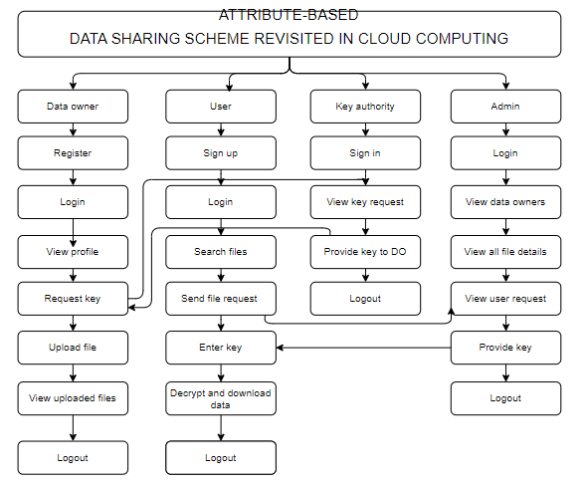

4. REQUIREMENT ANALYSIS
4.1 Functional and non-functional requirements
Requirement’s analysis is very critical process that enables the success of a system or software project to be assessed. Requirements are generally split into two types: Functional and non-functional requirements.
Functional Requirements: These are the requirements that the end user specifically demands as basic facilities that the system should offer. All these functionalities need to be necessarily incorporated into the system as a part of the contract. These are represented or stated in the form of input to be given to the system, the operation performed and the output expected. They are basically the requirements stated by the user which one can see directly in the final product, unlike the non-functional requirements.
Examples of functional requirements:
- Authentication of user whenever he/she logs into the system
- System shutdown in case of a cyber-attack
- A verification email is sent to user whenever he/she register for the first time on some software system.
Non-functional requirements: These are basically the quality constraints that the system must satisfy according to the project contract. The priority or extent to which these factors are implemented varies from one project to other. They are also called non-behavioral requirements.
They basically deal with issues like:
- Portability
- Security
- Maintainability
- Reliability
- Scalability
- Performance
- Reusability
- Flexibility

Examples of non-functional requirements:
- Emails should be sent with a latency of no greater than 12 hours from such an activity.

- The processing of each request should be done within 10 seconds
- The site should load in 3 seconds whenever of simultaneous users are > 10000
  - Hardware Requirements
Processor: Intel Core i5 (8th Gen) / AMD Ryzen 5 or higher
Hard Disk: 2 GB free (5 GB recommended with models + dataset)
Camera: 720p HD webcam @ 30 FPS (1080p recommended)
Microphone: Standard built-in (noise-cancelling recommended)
Monitor: 1366×768 resolution minimum
RAM: 8 GB DDR4 (16 GB recommended)
  - Software Requirements:
Operating System: Windows 10/11, macOS 11+, Ubuntu 20.04+
Frontend: HTML5, CSS3, JavaScript (ES6+), Three.js r150+
Programming Language: Python 3.10+
Libraries: Flask 3.x, Flask-SocketIO 5.x, TensorFlow 2.15+, MediaPipe 0.10+, OpenCV 4.8+, spaCy 3.x, gTTS 2.5+, deep-translator 1.11+
IDE: Visual Studio Code with Python and JavaScript extensions
Technology: Python 3.10+, TensorFlow.js 4.x (browser inference)
Server Deployment: Render (free tier) / Gunicorn WSGI
Database: SQLite 3.x with SQLAlchemy 2.x ORM

4.4Architecture:

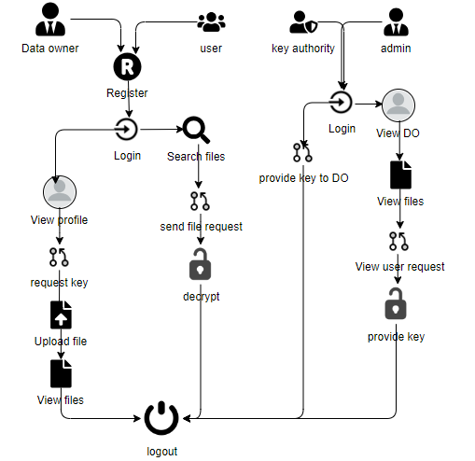

5. SYSTEM DESIGN
5.1 Introduction of Input Design:
In an information system, input is the raw data that is processed to produce output. During the input design, the developers must consider the input devices such as PC, MICR, OMR, etc.
Therefore, the quality of system input determines the quality of system output. Well-designed input forms and screens have following properties −
- It should serve specific purpose effectively such as storing, recording, and retrieving the information.
- It ensures proper completion with accuracy.
- It should be easy to fill and straightforward.
- It should focus on user’s attention, consistency, and simplicity.
- All these objectives are obtained using the knowledge of basic design principles regarding −
  - What are the inputs needed for the system?
  - How end users respond to different elements of forms and screens.

Objectives for Input Design:
The objectives of input design are −
- To design data entry and input procedures
- To reduce input volume
- To design source documents for data capture or devise other data capture methods
- To design input data records, data entry screens, user interface screens, etc.
- To use validation checks and develop effective input controls.

Output Design:

The design of output is the most important task of any system. During output design, developers identify the type of outputs needed, and consider the necessary output controls and prototype report layouts.

Objectives of Output Design:
The objectives of input design are:
- To develop output design that serves the intended purpose and eliminates the production of unwanted output.
- To develop the output design that meets the end user’s requirements.
- To deliver the appropriate quantity of output.
- To form the output in appropriate format and direct it to the right person.
- To make the output available on time for making good decisions.

5.2 UML Diagrams:
5.2.1 Use Case Diagram:
A use case diagram in the Unified Modeling Language (UML) is a type of behavioral diagram defined by and created from a Use-case analysis. Its purpose is to present a graphical overview of the functionality provided by a system in terms of actors, their goals (represented as use cases), and any dependencies between those use cases. The main purpose of a use case diagram is to show what system functions are performed for which actor. Roles of the actors in the system can be depicted.
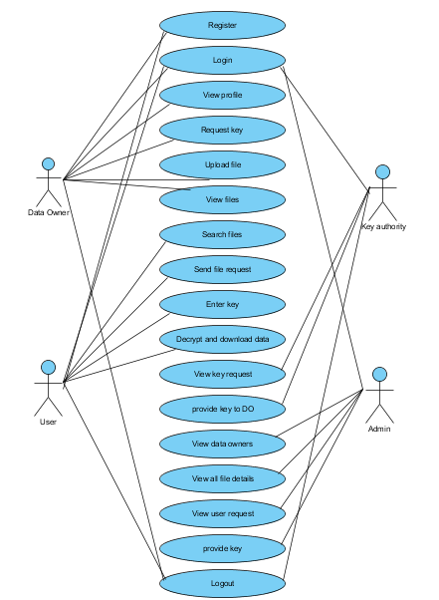

5.2.2 Class Diagram:
In software engineering, a class diagram in the Unified Modelling Language (UML) is a type of static structure diagram that describes the structure of a system by showing the system's classes, their attributes, operations (or methods), and the relationships among the classes. It explains which class contains information.
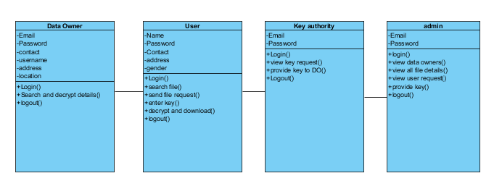

5.2.3 Sequence Diagram:
A sequence diagram in Unified Modelling Language (UML) is a kind of interaction diagram that shows how processes operate with one another and in what order. It is a construct of a Message Sequence Chart. Sequence diagrams are sometimes called event diagrams, event scenarios, and timing diagrams.

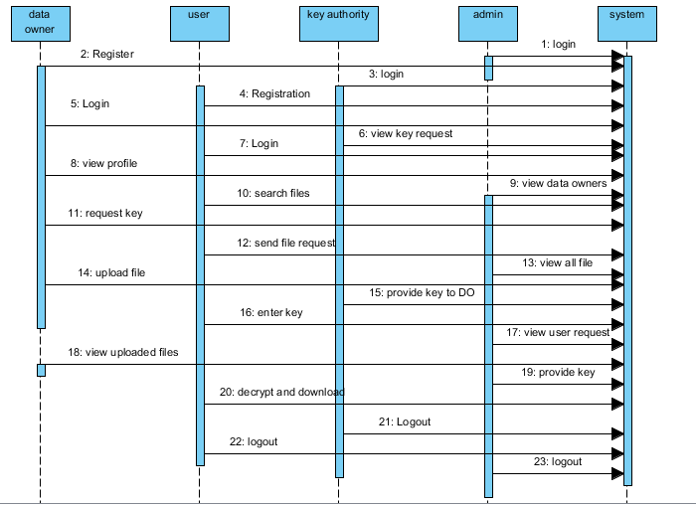

5.2.4 Collaboration Diagram:
In collaboration diagram the method call sequence is indicated by some numbering technique as shown below. The number indicates how the methods are called one after another. We have taken the same order management system to describe the collaboration diagram. The method calls are similar to that of a sequence diagram. But the difference is that the sequence diagram does not describe the object organization whereas the collaboration diagram shows the object organization.
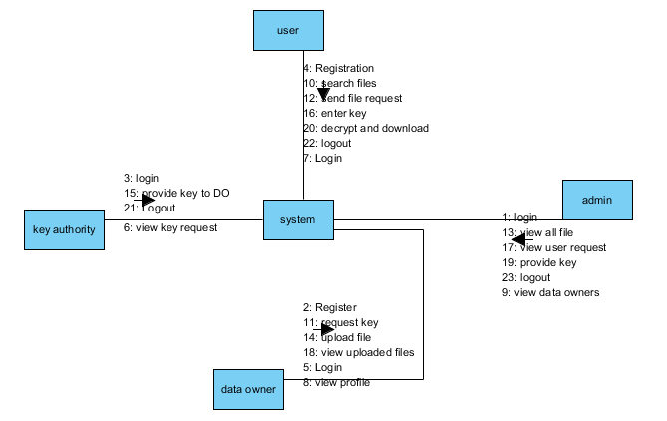
5.2.5 Deployment Diagram
Deployment diagram represents the deployment view of a system. It is related to the component diagram. Because the components are deployed using the deployment diagrams. A deployment diagram consists of nodes. Nodes are nothing but physical hardware’s used to deploy the application. 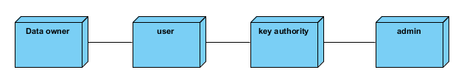

5.2.6 Activity Diagram:
Activity diagrams are graphical representations of workflows of stepwise activities and actions with support for choice, iteration and concurrency. In the Unified Modelling Language, activity diagrams can be used to describe the business and operational step-by-step workflows of components in a system. An activity diagram shows the overall flow of control.
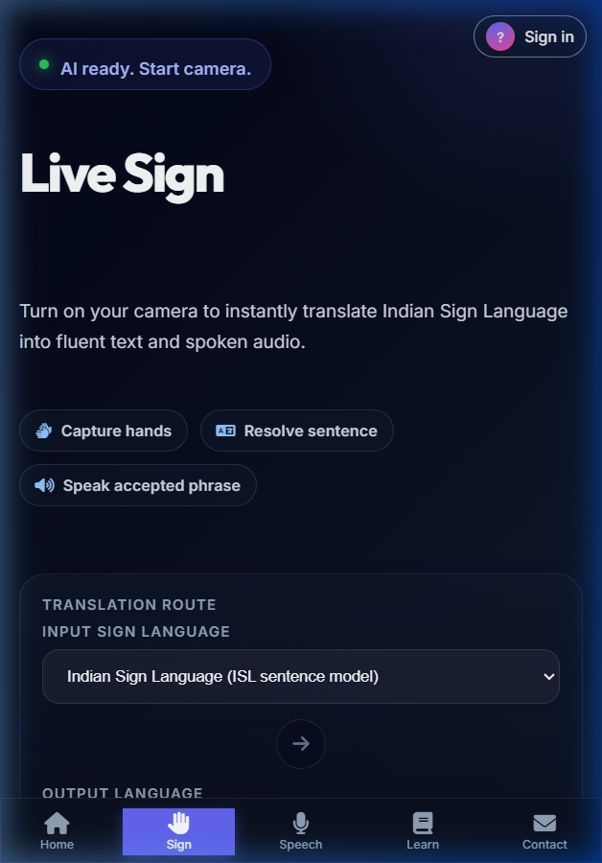

5.2.7 Component Diagram:
A component diagram, also known as a UML component diagram, describes the organization and wiring of the physical components in a system. Component diagrams are often drawn to help model implementation details and double-check that every aspect of the system's required functions is covered by planned development.
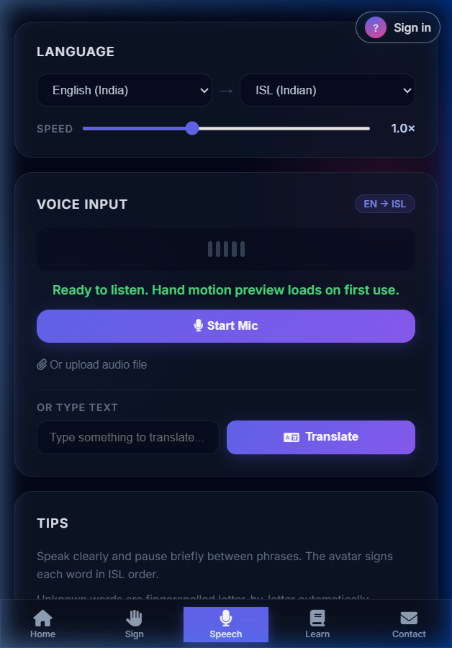

5.2.8 ER Diagram:
An Entity–relationship model (ER model) describes the structure of a database with the help of a diagram, which is known as Entity Relationship Diagram (ER Diagram). An ER model is a design or blueprint of a database that can later be implemented as a database. The main components of E-R model are: entity set and relationship set.
An ER diagram shows the relationship among entity sets. An entity set is a group of similar entities and these entities can have attributes. In terms of DBMS, an entity is a table or attribute of a table in database, so by showing relationship among tables and their attributes, ER diagram shows the complete logical structure of a database. Let’s have a look at a simple ER diagram to understand this concept.

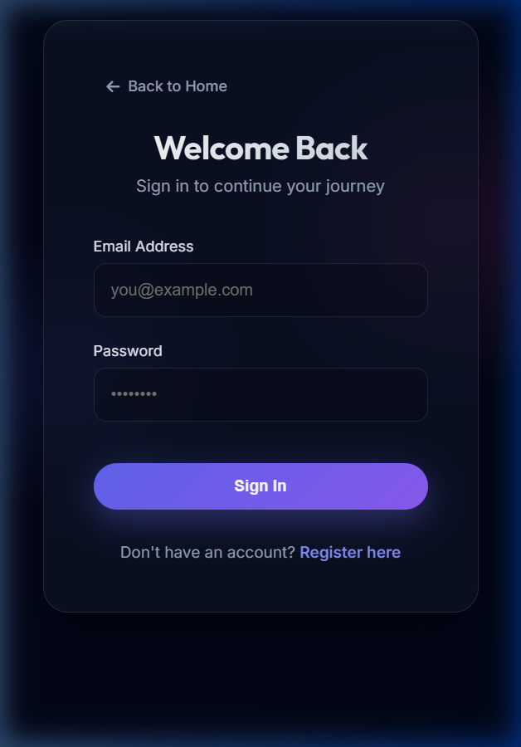

5.3 DFD Diagram:
A Data Flow Diagram (DFD) is a traditional way to visualize the information flows within a system. A neat and clear DFD can depict a good amount of the system requirements graphically. It can be

manual, automated, or a combination of both. It shows how information enters and leaves the system, what changes the information and where information is stored. The purpose of a DFD is to show the scope and boundaries of a system as a whole. It may be used as a communications tool between a systems analyst and any person who plays a part in the system that acts as the starting point for redesigning a system.

Level 0 Diagram:

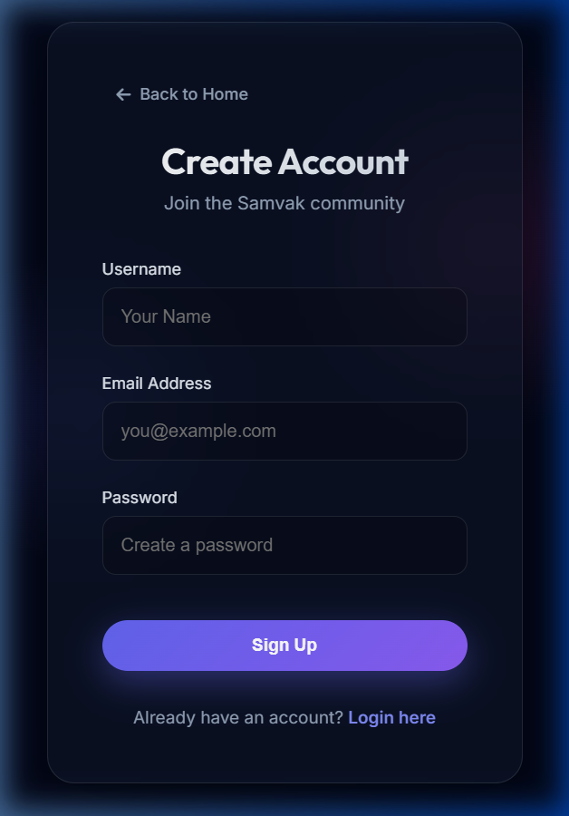

Level 1 Diagram:

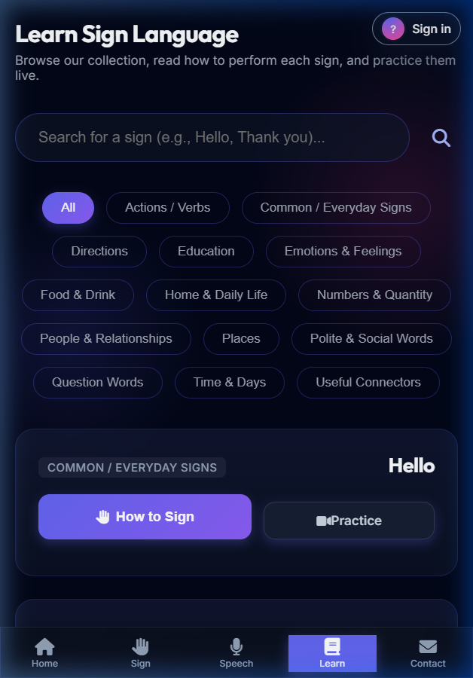

Level 2 Diagram:

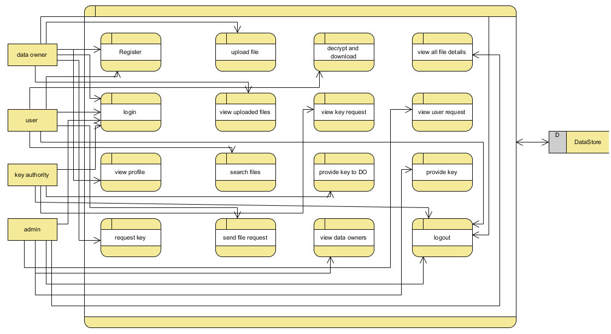

6.CODE, IMPLEMENTATION AND RESULT
CLOUDHOME.HTML :-
<!DOCTYPE html>
<html>

<head>
<!-- Basic -->
<meta charset="utf-8" />
<meta http-equiv="X-UA-Compatible" content="IE=edge" />
<!-- Mobile Metas -->
<meta name="viewport" content="width=device-width, initial-scale=1, shrink-to-fit=no" />
<!-- Site Metas -->
<meta name="keywords" content="" />
<meta name="description" content="" />
<meta name="author" content="" />

<title>Intot</title>

<!-- slider stylesheet -->
<link rel="stylesheet" type="text/css"
href="https://cdnjs.cloudflare.com/ajax/libs/OwlCarousel2/2.1.3/assets/owl.carousel.min.css" />

<!-- bootstrap core css -->
<link rel="stylesheet" type="text/css" href="/static/css/bootstrap.css" />

<!-- fonts style -->
<link href="https://fonts.googleapis.com/css?family=Dosis:400,500|Poppins:400,600,700&display=swap" rel="stylesheet">
<!-- Custom styles for this template -->
<link href="/static/css/style.css" rel="stylesheet" />
<!-- responsive style -->
<link href="/static/css/responsive.css" rel="stylesheet" />
</head>

<body>
<div class="hero_area">
<!-- header section strats -->
<header class="header_section">
<div class="container-fluid">
<nav class="navbar navbar-expand-lg custom_nav-container">
<a class="navbar-brand" href="index.html">
<span>
MULTI-LINGUAL SIGN LANGUAGE TO SPEECH AND SPEECH TO SIGN TRANSLATOR

</span>
</a>

<div class="navbar-collapse" id="">
<div class="d-none d-lg-flex ml-auto flex-column flex-lg-row align-items-center">

<!-- <form class="form-inline my-2 mb-3 mb-lg-0 mr-5">
<button class="btn my-2 my-sm-0 nav_search-btn" type="submit"></button>
</form> -->
</div>

<div class="custom_menu-btn">
<button onclick="openNav()">
<span class="s-1">

</span>
<span class="s-2">

</span>
<span class="s-3">

</span>
</button>
</div>
<div id="myNav" class="overlay">
<div class="overlay-content">
<a href="{{url_for('viewowner')}}" >View Data Owner</a>
<a href="{{url_for('viewuser')}}">View Data User</a>
<a href="{{url_for('viewallfile')}}">View all files</a>
<a href="{{url_for('viewequest')}}">Key Description</a>
<a href="/">Logout</a>

</div>
</div>
</div>
</nav>
</div>
</header>
<!-- end header section -->
<!-- slider section -->
<section class=" slider_section position-relative">
<div id="carouselExampleIndicators" class="carousel slide" data-ride="carousel">
<div class="carousel-inner">

<div class="carousel-item active">
<div class="row">
<div class="col-md-3 offset-md-2">
<div class="slider_detail">
<h1>
Welcome to
<span>
Cloud homepage
</span>
</h1>
<p>

</p>
<div>
</div>
</div>
</div>
<div class="col-md-7">
<div class="slider_img-box">
<img src="/static/images/slider-img.png" alt="">
</div>
</div>
</div>
</div>
</div>
</div>

</section>

<!-- end slider section -->
</div>

<!-- end info section -->
<hr class="footer_hr">
<!-- footer section -->
<section class="container-fluid footer_section">
<p>
&copy;
2019 All Rights Reserved. Design by
<a href="https://html.design/">Free Html Templates</a>
</p>
</section>
<!-- footer section -->

<script type="text/javascript" src="/static/js/jquery-3.4.1.min.js"></script>
<script type="text/javascript" src="/static/js/bootstrap.js"></script>

<script>
function openNav() {
document.getElementById("myNav").classList.toggle("menu_width")
document.querySelector(".custom_menu-btn").classList.toggle("menu_btn-style")
}
</script>
</body>

</html>

CLOUDLOGIN.HTML:

<!DOCTYPE html>
<html>

<head>
<!-- Basic -->
<meta charset="utf-8" />
<meta http-equiv="X-UA-Compatible" content="IE=edge" />
<!-- Mobile Metas -->
<meta name="viewport" content="width=device-width, initial-scale=1, shrink-to-fit=no" />
<!-- Site Metas -->
<meta name="keywords" content="" />
<meta name="description" content="" />
<meta name="author" content="" />

<title>Intot</title>

<!-- slider stylesheet -->
<link rel="stylesheet" type="text/css"
href="https://cdnjs.cloudflare.com/ajax/libs/OwlCarousel2/2.1.3/assets/owl.carousel.min.css" />
<!-- bootstrap core css -->
<link rel="stylesheet" type="text/css" href="/static/css/bootstrap.css" />
<!-- fonts style -->
<link href="https://fonts.googleapis.com/css?family=Dosis:400,500|Poppins:400,600,700&display=swap" rel="stylesheet">
<!-- Custom styles for this template -->
<link href="/static/css/style.css" rel="stylesheet" />

<!-- responsive style -->

<link href="/static/css/responsive.css" rel="stylesheet" />

</head>

<body class="sub_page">

<body class="">
<div class="hero_area">
<!-- header section strats -->
<header class="header_section">
<div class="container-fluid">
<nav class="navbar navbar-expand-lg custom_nav-container">
<a class="navbar-brand" href="index.html">
<span>
SIGN LANGUAGE TRANSLATION
</span>
</a>

<div class="navbar-collapse" id="">
<div class="d-none d-lg-flex ml-auto flex-column flex-lg-row align-items-center">

<form class="form-inline my-2 mb-3 mb-lg-0 mr-5">
<button class="btn my-2 my-sm-0 nav_search-btn" type="submit"></button>
</form>
</div>

<div class="custom_menu-btn">
<button onclick="openNav()">
<span class="s-1">

</span>
<span class="s-2">

</span>
<span class="s-3">
</span>
</button>
</div>
<div id="myNav" class="overlay">
<div class="overlay-content">
<a href="{{url_for('dataownerlogin')}}" >Data Owner</a>

<a href="{{url_for('datauserlogin')}}">Data User</a>
<a href="{{url_for('tpalogin')}}">Key Authority</a>
<a href="{{url_for('cloudlogin')}}">Admin/Cloud</a>

</div>
</div>
</div>
</nav>
</div>
</header>
<!-- end header section -->
</div>
<!-- contact section -->
<section class="contact_section layout_padding">
<div class="container">
<h2 class="">
Cloud Login
</h2>
</div>
<div class="container">

<div class="row">
<div class="col-md-6 " style="
left: 298px;
">
<center> <form action="{{ url_for('cloudlogin') }}" class="hero-form" method="post" enctype="multipart/form-data">
<div class="contact_form-container">
<div>
<div>
<label>
<input type="email" class="form-control bg-dark border-0 px-4" name="cloudemail" id="cloudemail" placeholder="Enter email" style="height: 55px;border-radius:20px;">
</label>
</div>
<div>
<label>
<input type="password" class="form-control bg-dark border-0 px-4" name="password" id="password" placeholder="Enter Password" style="height: 55px;border-radius:20px;">
</label>
</div>
<div class="mt-5">
<button type="submit">

Send
</button>

</div>

</div>
</div>
</form>
</div>
</div>
</div>
</section>
<!-- end contact section -->
<script type="text/javascript" src="/static/js/jquery-3.4.1.min.js"></script>
<script type="text/javascript" src="/static/js/bootstrap.js"></script>
<script>
function openNav() {
document.getElementById("myNav").classList.toggle("menu_width")
document.querySelector(".custom_menu-btn").classList.toggle("menu_btn-style")
}
</script>
</body>
</html>

DOWN.HTML:

<!DOCTYPE html>
<html>
<head>
<!-- Basic -->
<meta charset="utf-8" />
<meta http-equiv="X-UA-Compatible" content="IE=edge" />
<!-- Mobile Metas -->
<meta name="viewport" content="width=device-width, initial-scale=1, shrink-to-fit=no" />
<!-- Site Metas -->
<meta name="keywords" content="" />
<meta name="description" content="" />
<meta name="author" content="" />

<title>Intot</title>

<!-- slider stylesheet -->

<link rel="stylesheet" type="text/css"

href="https://cdnjs.cloudflare.com/ajax/libs/OwlCarousel2/2.1.3/assets/owl.carousel.min.css" />

<!-- bootstrap core css -->
<link rel="stylesheet" type="text/css" href="/static/css/bootstrap.css" />

<!-- fonts style -->
<link href="https://fonts.googleapis.com/css?family=Dosis:400,500|Poppins:400,600,700&display=swap" rel="stylesheet">
<!-- Custom styles for this template -->
<link href="/static/css/style.css" rel="stylesheet" />
<!-- responsive style -->
<link href="/static/css/responsive.css" rel="stylesheet" />
</head>

<body class="sub_page">

<body class="">
<div class="hero_area">
<!-- header section strats -->
<header class="header_section">
<div class="container-fluid">
<nav class="navbar navbar-expand-lg custom_nav-container">
<a class="navbar-brand" href="index.html">
<span>
SIGN LANGUAGE TRANSLATION
</span>
</a>

<div class="navbar-collapse" id="">
<div class="d-none d-lg-flex ml-auto flex-column flex-lg-row align-items-center">

<form class="form-inline my-2 mb-3 mb-lg-0 mr-5">
<button class="btn my-2 my-sm-0 nav_search-btn" type="submit"></button>
</form>
</div>

<div class="custom_menu-btn">
<button onclick="openNav()">
<span class="s-1">

</span>
<span class="s-2">

</span>
<span class="s-3">

</span>
</button>
</div>
<div id="myNav" class="overlay">

<div class="overlay-content">
<a href="{{url_for('search')}}">Search file</a>
<a href="{{url_for('viewkeydetails')}}" >Key Details</a>
<a href="{{url_for('download')}}">Download files</a>
<a href="/">Logout</a>

</div>
</div>
</div>
</nav>
</div>
</header>
<!-- end header section -->
</div>
<!-- contact section -->
<section class="contact_section layout_padding">
<div class="container">
<h2 class="">
Download Files
</h2>
</div>
<div class="container">
<div class="row">
<div class="col-md-6 " style="
left: 298px;
">
<center> <form action="{{ url_for('readkey') }}" class="hero-form" method="post" enctype="multipart/form-data">
<div class="contact_form-container">
<input type="hidden" name="id" value="{{id}}">
<div>
<div>
<label>
<input type="text" class="form-control bg-dark border-0 px-4" name="Secratekey1" id="Secratekey1" placeholder="Enter key1" style="height: 55px;border-radius:20px;">

</label>

</div>
\
<div>
<label>
<input type="text" class="form-control bg-dark border-0 px-4" name="Secratekey2" id="Secratekey2" placeholder="Enter Key2" style="height: 55px;border-radius:20px;">
</label>
</div>

<div class="mt-5">
<button type="submit">
Download
</button>
</div>

</div>
</div>
</form>
</div>
</div>
</div>
</section>
<!-- end contact section -->
<script type="text/javascript" src="/static/js/jquery-3.4.1.min.js"></script>
<script type="text/javascript" src="/static/js/bootstrap.js"></script>
<script>
function openNav() {
document.getElementById("myNav").classList.toggle("menu_width")
document.querySelector(".custom_menu-btn").classList.toggle("menu_btn-style")
}
</script>
</body>

</html>

DOWNLOAD.HTML:

<!DOCTYPE html>
<html>
<head>
<!-- Basic -->

<meta charset="utf-8" />
<meta http-equiv="X-UA-Compatible" content="IE=edge" />
<!-- Mobile Metas -->

<meta name="viewport" content="width=device-width, initial-scale=1, shrink-to-fit=no" />
<!-- Site Metas -->
<meta name="keywords" content="" />
<meta name="description" content="" />
<meta name="author" content="" />

<title>Intot</title>

<!-- slider stylesheet -->
<link rel="stylesheet" type="text/css"
href="https://cdnjs.cloudflare.com/ajax/libs/OwlCarousel2/2.1.3/assets/owl.carousel.min.css" />

<!-- bootstrap core css -->
<link rel="stylesheet" type="text/css" href="/static/css/bootstrap.css" />

<!-- fonts style -->
<link href="https://fonts.googleapis.com/css?family=Dosis:400,500|Poppins:400,600,700&display=swap" rel="stylesheet">
<!-- Custom styles for this template -->
<link href="/static/css/style.css" rel="stylesheet" />
<!-- responsive style -->
<link href="/static/css/responsive.css" rel="stylesheet" />
</head>

<body class="sub_page">

<body class="">
<div class="hero_area">
<!-- header section strats -->
<header class="header_section">
<div class="container-fluid">
<nav class="navbar navbar-expand-lg custom_nav-container">
<a class="navbar-brand" href="index.html">
<span>
SIGN LANGUAGE TRANSLATION
</span>
</a>

<div class="navbar-collapse" id="">

<div class="d-none d-lg-flex ml-auto flex-column flex-lg-row align-items-center">

<form class="form-inline my-2 mb-3 mb-lg-0 mr-5">
<button class="btn my-2 my-sm-0 nav_search-btn" type="submit"></button>
</form>

</div>

<div class="custom_menu-btn">
<button onclick="openNav()">
<span class="s-1">

</span>
<span class="s-2">

</span>
<span class="s-3">

</span>
</button>
</div>
<div id="myNav" class="overlay">
<div class="overlay-content">
<a href="{{url_for('search')}}">Search file</a>
<a href="{{url_for('viewkeydetails')}}" >Key Details</a>
<a href="{{url_for('download')}}">Download files</a>
<a href="/">Logout</a>

</div>
</div>
</div>
</nav>
</div>
</header>
<!-- end header section -->
</div>
<center>
<h1 class="section-title bg-white text-center text-primary px-3">
VIEW Secure Keys
</h1>
</center><br><br>
<center style="

width: 1786px;
">
<div class="container text-center">
<table class="table">
<thead>
<tr>
<th>Id</th>

<th>Filename</th>
<th>Encrypted Data</th>
<th>key1</th>
<th>Key2</th>
<th>Action</th>
</tr>
</thead>
<tbody>
{% for row in row_val %}

<tr>
<td>{{ row[0] }}</td>

<td>{{ row[3] }}</td>
<td>{{ row[4] }}</td>
<td>{{ row[5] }}</td>
<td>{{ row[6] }}</td>
<td><a style="color:rgb(0, 195, 140);" href="{{ url_for('down', id=row[0],filename=row[3]) }}" type="submit">Download File</a></td>
</tr>
{% endfor %}
</tbody>
</table>
</div>
</center>
<!-- end contact section -->
<script type="text/javascript" src="/static/js/jquery-3.4.1.min.js"></script>
<script type="text/javascript" src="/static/js/bootstrap.js"></script>
<script>
function openNav() {
document.getElementById("myNav").classList.toggle("menu_width")
document.querySelector(".custom_menu-btn").classList.toggle("menu_btn-style")
}
</script>
</body>

</html>

INDEX.HTML:

<!DOCTYPE html>
<html>

<head>

<!-- Basic -->
<meta charset="utf-8" />
<meta http-equiv="X-UA-Compatible" content="IE=edge" />
<!-- Mobile Metas -->
<meta name="viewport" content="width=device-width, initial-scale=1, shrink-to-fit=no" />
<!-- Site Metas -->
<meta name="keywords" content="" />
<meta name="description" content="" />
<meta name="author" content="" />

<title>Intot</title>

<!-- slider stylesheet -->
<link rel="stylesheet" type="text/css"
href="https://cdnjs.cloudflare.com/ajax/libs/OwlCarousel2/2.1.3/assets/owl.carousel.min.css" />

<!-- bootstrap core css -->
<link rel="stylesheet" type="text/css" href="/static/css/bootstrap.css" />

<!-- fonts style -->
<link href="https://fonts.googleapis.com/css?family=Dosis:400,500|Poppins:400,600,700&display=swap" rel="stylesheet">
<!-- Custom styles for this template -->
<link href="/static/css/style.css" rel="stylesheet" />
<!-- responsive style -->
<link href="/static/css/responsive.css" rel="stylesheet" />
</head>

<body>
<div class="hero_area">
<!-- header section strats -->
<header class="header_section">
<div class="container-fluid">
<nav class="navbar navbar-expand-lg custom_nav-container">

<a class="navbar-brand" href="index.html">
<span>
SIGN LANGUAGE TRANSLATION
</span>
</a>

<div class="navbar-collapse" id="">
<div class="d-none d-lg-flex ml-auto flex-column flex-lg-row align-items-center">
<!-- <form class="form-inline my-2 mb-3 mb-lg-0 mr-5">
<button class="btn my-2 my-sm-0 nav_search-btn" type="submit"></button>

</form> -->
</div>

<div class="custom_menu-btn">
<button onclick="openNav()">
<span class="s-1">

</span>
<span class="s-2">

</span>

<span class="s-3">

</span>
</button>
</div>
<div id="myNav" class="overlay">
<div class="overlay-content">
<a href="{{url_for('dataownerlogin')}}" >Data Owner</a>
<a href="{{url_for('datauserlogin')}}">Data User</a>
<a href="{{url_for('tpalogin')}}">Key Authority</a>
<a href="{{url_for('cloudlogin')}}">Admin/Cloud</a>
</div>
</div>
</div>
</nav>
</div>
</header>
<!-- end header section -->
<!-- slider section -->
<section class=" slider_section position-relative">

<div id="carouselExampleIndicators" class="carousel slide" data-ride="carousel">
<div class="carousel-inner">
<div class="carousel-item active">
<div class="row">
<div class="col-md-3 offset-md-2">
<div class="slider_detail">
<h1>
MULTI-LINGUAL SIGN LANGUAGE TO SPEECH AND SPEECH TO SIGN TRANSLATOR
<span>
REVISITED IN SIGN LANGUAGE TRANSLATION
</span>

</h1>
<p>

</p>
<div>
</div>
</div>
</div>
<div class="col-md-7">
<div class="slider_img-box">
<img src="/static/images/slider-img.png" alt="">
</div>

</div>
</div>
</div>
</div>
</div>

</section>

<!-- end slider section -->
</div>

<!-- end info section -->
<hr class="footer_hr">
<!-- footer section -->
<section class="container-fluid footer_section">
<p>
&copy;
2019 All Rights Reserved. Design by

<a href="https://html.design/">Free Html Templates</a>
</p>
</section>
<!-- footer section -->

<script type="text/javascript" src="/static/js/jquery-3.4.1.min.js"></script>
<script type="text/javascript" src="/static/js/bootstrap.js"></script>
<script>
function openNav() {
document.getElementById("myNav").classList.toggle("menu_width")
document.querySelector(".custom_menu-btn").classList.toggle("menu_btn-style")
}
</script>

</body>

</html>
KEYREQUEST.HTML:

<!DOCTYPE html>
<html>
<head>
<!-- Basic -->
<meta charset="utf-8" />
<meta http-equiv="X-UA-Compatible" content="IE=edge" />
<!-- Mobile Metas -->
<meta name="viewport" content="width=device-width, initial-scale=1, shrink-to-fit=no" />
<!-- Site Metas -->
<meta name="keywords" content="" />
<meta name="description" content="" />
<meta name="author" content="" />
<title>Intot</title>
<!-- slider stylesheet -->
<link rel="stylesheet" type="text/css"
href="https://cdnjs.cloudflare.com/ajax/libs/OwlCarousel2/2.1.3/assets/owl.carousel.min.css" />
<!-- bootstrap core css -->
<link rel="stylesheet" type="text/css" href="/static/css/bootstrap.css" />
<!-- fonts style -->
<link href="https://fonts.googleapis.com/css?family=Dosis:400,500|Poppins:400,600,700&display=swap" rel="stylesheet">
<!-- Custom styles for this template -->
<link href="/static/css/style.css" rel="stylesheet" />
<!-- responsive style -->
<link href="/static/css/responsive.css" rel="stylesheet" />
</head>
<body class="sub_page">
<body class="">
<div class="hero_area">
<!-- header section strats -->
<header class="header_section">
<div class="container-fluid">
<nav class="navbar navbar-expand-lg custom_nav-container">
<a class="navbar-brand" href="index.html">
<span>
SIGN LANGUAGE TRANSLATION
</span>
</a>
<div class="navbar-collapse" id="">
<div class="d-none d-lg-flex ml-auto flex-column flex-lg-row align-items-center">
<form class="form-inline my-2 mb-3 mb-lg-0 mr-5">
<button class="btn my-2 my-sm-0 nav_search-btn" type="submit"></button>
</form>
</div>
<div class="custom_menu-btn">
<button onclick="openNav()">
<span class="s-1">
</span>
<span class="s-2">
</span>
<span class="s-3">
</span>
</button>
</div>
<div id="myNav" class="overlay">
<div class="overlay-content">
<a href="{{url_for('viewprofile')}}" >Profile</a>
<a href="{{url_for('keyrequest')}}">Request Key</a>
<a href="{{url_for('upload')}}">Upload File</a>
<a href="{{url_for('viewmyfile')}}">File Deatils</a>
<a href="/">Logout</a>
</div>
</div>
</div>
</nav>
</div>
</header>
<!-- end header section -->
</div>
<center>
<h1 class="section-title bg-white text-center text-primary px-3">
Key Request
</h1>
</center><br><br>
<center> <div class="container text-center">
<div class="row align-items-start" >
{% for row in row_val %}
<div class="col" >
<div class="card" style="width: 22rem;border-radius:20px;left: 384px;">
<div class="card-body">
<b><p class="news_taital" style="color:black;">
Name : {{row[1]}}
</p></b>
<p class="long_text" style="color:black;">
Email: {{row[2]}}
</p>
<p class="long_text" style="color:black;">
Password: {{row[3]}}
</p>
<p class="long_text" style="color:black;">
Contact Number: {{row[4]}}
</p>
<p class="long_text" style="color:black;">
Address: {{row[5]}}
</p>
<p class="long_text" style="color:black;">
Master_key: {{row[6]}}
</p>
<a style="color:rgb(0, 195, 140);" href="{{ url_for('requestkey', id=row[0]) }}" type="submit">Request key</a>
</div>
</div>
</div>
{% endfor %}
</div>
</div></center>
<!-- end contact section -->
<script type="text/javascript" src="/static/js/jquery-3.4.1.min.js"></script>
<script type="text/javascript" src="/static/js/bootstrap.js"></script>
<script>
function openNav() {
document.getElementById("myNav").classList.toggle("menu_width")
document.querySelector(".custom_menu-btn").classList.toggle("menu_btn-style")
}
</script>
</body>
</html>

OWNERHOME.HTML:

<!DOCTYPE html>
<html>
<head>
<!-- Basic -->
<meta charset="utf-8" />
<meta http-equiv="X-UA-Compatible" content="IE=edge" />
<!-- Mobile Metas -->
<meta name="viewport" content="width=device-width, initial-scale=1, shrink-to-fit=no" />
<!-- Site Metas -->
<meta name="keywords" content="" />
<meta name="description" content="" />
<meta name="author" content="" />
<title>Intot</title>
<!-- slider stylesheet -->
<link rel="stylesheet" type="text/css"
href="https://cdnjs.cloudflare.com/ajax/libs/OwlCarousel2/2.1.3/assets/owl.carousel.min.css" />
<!-- bootstrap core css -->
<link rel="stylesheet" type="text/css" href="/static/css/bootstrap.css" />
<!-- fonts style -->
<link href="https://fonts.googleapis.com/css?family=Dosis:400,500|Poppins:400,600,700&display=swap" rel="stylesheet">
<!-- Custom styles for this template -->
<link href="/static/css/style.css" rel="stylesheet" />
<!-- responsive style -->
<link href="/static/css/responsive.css" rel="stylesheet" />
MULTI-LINGUAL SIGN LANGUAGE TO SPEECH AND SPEECH TO SIGN TRANSLATOR
<!-- <form class="form-inline my-2 mb-3 mb-lg-0 mr-5">
<button class="btn my-2 my-sm-0 nav_search-btn" type="submit"></button>

</form> -->
</div>
<div class="custom_menu-btn">
<button onclick="openNav()">
<span class="s-1">
</span>
<span class="s-2">
</span>
<span class="s-3">
</span>
</button>
</div>
<div id="myNav" class="overlay">
<div class="overlay-content">
<a href="{{url_for('viewprofile')}}" >Profile</a>
<a href="{{url_for('keyrequest')}}">Request Key</a>
<a href="{{url_for('upload')}}">Upload File</a>
<a href="{{url_for('viewmyfile')}}">File Deatils</a>
<a href="/">Logout</a>
</div>
</div>
</div>
</nav>
</div>
</header>
<!-- end header section -->
<!-- slider section -->
<section class=" slider_section position-relative">
<div id="carouselExampleIndicators" class="carousel slide" data-ride="carousel">
<div class="carousel-inner">
<div class="carousel-item active">
<div class="row">
<div class="col-md-3 offset-md-2">
<div class="slider_detail">
<h1>
Welcome to
<span>
Data owner Home page
</span>
</h1>
<p>
</p>
<div>
</div>
</div>
</div>
<div class="col-md-7">
<div class="slider_img-box">
<img src="/static/images/slider-img.png" alt="">
</div>
</div>
</div>
</div>
</div>
</div>
</section>
<!-- end slider section -->
</div>
<!-- end info section -->
<hr class="footer_hr">
<!-- footer section -->
<section class="container-fluid footer_section">
<p>
&copy;
2019 All Rights Reserved. Design by
<a href="https://html.design/">Free Html Templates</a>
</p>
</section>
<!-- footer section -->
<script type="text/javascript" src="/static/js/jquery-3.4.1.min.js"></script>
<script type="text/javascript" src="/static/js/bootstrap.js"></script>
<script>
function openNav() {
document.getElementById("myNav").classList.toggle("menu_width")
document.querySelector(".custom_menu-btn").classList.toggle("menu_btn-style")
}
</script>
</body>
</html>

OWNERLOGIN.HTML:

<!DOCTYPE html>
<html>
<head>
<!-- Basic -->
<meta charset="utf-8" />
<meta http-equiv="X-UA-Compatible" content="IE=edge" />
<!-- Mobile Metas -->
<meta name="viewport" content="width=device-width, initial-scale=1, shrink-to-fit=no" />
<!-- Site Metas -->
<meta name="keywords" content="" />
<meta name="description" content="" />
<meta name="author" content="" />
<title>Intot</title>
<!-- slider stylesheet -->
<link rel="stylesheet" type="text/css"
href="https://cdnjs.cloudflare.com/ajax/libs/OwlCarousel2/2.1.3/assets/owl.carousel.min.css" />
<!-- bootstrap core css -->
<link rel="stylesheet" type="text/css" href="/static/css/bootstrap.css" />
<!-- fonts style -->
<link href="https://fonts.googleapis.com/css?family=Dosis:400,500|Poppins:400,600,700&display=swap" rel="stylesheet">
<!-- Custom styles for this template -->
<link href="/static/css/style.css" rel="stylesheet" />
<!-- responsive style -->
<link href="/static/css/responsive.css" rel="stylesheet" />
</head>
<body class="sub_page">
<body class="">
<div class="hero_area">
<!-- header section strats -->
<header class="header_section">
<div class="container-fluid">
<nav class="navbar navbar-expand-lg custom_nav-container">
<a class="navbar-brand" href="index.html">
<span>
SIGN LANGUAGE TRANSLATION
</span>
</a>
<div class="navbar-collapse" id="">
<div class="d-none d-lg-flex ml-auto flex-column flex-lg-row align-items-center">
<form class="form-inline my-2 mb-3 mb-lg-0 mr-5">
<button class="btn my-2 my-sm-0 nav_search-btn" type="submit"></button>
</form>
</div>
<div class="custom_menu-btn">
<button onclick="openNav()">
<span class="s-1">
</span>
<span class="s-2">
</span>
<span class="s-3">
</span>
</button>
</div>
<div id="myNav" class="overlay">
<div class="overlay-content">
<a href="{{url_for('dataownerlogin')}}" >Data Owner</a>
<a href="{{url_for('datauserlogin')}}">Data User</a>
<a href="{{url_for('tpalogin')}}">Key Authority</a>
<a href="{{url_for('cloudlogin')}}">Admin/Cloud</a>
</div>
</div>
</div>
</nav>
</div>
</header>
<!-- end header section -->
</div>
<!-- contact section -->
<section class="contact_section layout_padding">
<div class="container">
<h2 class="">
Data Owner Login
</h2>
</div>
<div class="container">
<div class="row">
<div class="col-md-6 " style="
left: 298px;
">
<center> <form action="{{ url_for('dataownerlogin') }}" class="hero-form" method="post" enctype="multipart/form-data">
<div class="contact_form-container">
<div>
<div>
<label>
<input type="email" class="form-control bg-dark border-0 px-4" name="email" id="sname" placeholder="Enter email" style="height: 55px;border-radius:20px;">
</label>
</div>
<div>
<label>
<input type="password" class="form-control bg-dark border-0 px-4" name="pwd" id="pwd" placeholder="Enter Password" style="height: 55px;border-radius:20px;">
</label>
</div>
<div class="mt-5">
<button type="submit">
Send
</button>
</div>
<a style="color:rgb(0, 195, 140);" href="{{ url_for('ownerreg')}}" type="submit" >Don't have an account?<b> Registration</a> </b>
</div>
</div>
</form>
</div>
</div>
</div>
</section>
<!-- end contact section -->
<script type="text/javascript" src="/static/js/jquery-3.4.1.min.js"></script>
<script type="text/javascript" src="/static/js/bootstrap.js"></script>
<script>
function openNav() {
document.getElementById("myNav").classList.toggle("menu_width")
document.querySelector(".custom_menu-btn").classList.toggle("menu_btn-style")
}
</script>
</body>
</html>

REG.HTML:

<!DOCTYPE html>
<html>
<head>
<!-- Basic -->
<meta charset="utf-8" />
<meta http-equiv="X-UA-Compatible" content="IE=edge" />
<!-- Mobile Metas -->
<meta name="viewport" content="width=device-width, initial-scale=1, shrink-to-fit=no" />
<!-- Site Metas -->
<meta name="keywords" content="" />
<meta name="description" content="" />
<meta name="author" content="" />
<title>Intot</title>
<!-- slider stylesheet -->
<link rel="stylesheet" type="text/css"
href="https://cdnjs.cloudflare.com/ajax/libs/OwlCarousel2/2.1.3/assets/owl.carousel.min.css" />
<!-- bootstrap core css -->
<link rel="stylesheet" type="text/css" href="/static/css/bootstrap.css" />
<!-- fonts style -->
<link href="https://fonts.googleapis.com/css?family=Dosis:400,500|Poppins:400,600,700&display=swap" rel="stylesheet">
<!-- Custom styles for this template -->
<link href="/static/css/style.css" rel="stylesheet" />
<!-- responsive style -->
<link href="/static/css/responsive.css" rel="stylesheet" />
</head>
<body class="sub_page">
<body class="">
<div class="hero_area">
<!-- header section strats -->
<header class="header_section">
<div class="container-fluid">
<nav class="navbar navbar-expand-lg custom_nav-container">
<a class="navbar-brand" href="index.html">
<span>
SIGN LANGUAGE TRANSLATION
</span>
</a>
<div class="navbar-collapse" id="">
<div class="d-none d-lg-flex ml-auto flex-column flex-lg-row align-items-center">
<form class="form-inline my-2 mb-3 mb-lg-0 mr-5">
<button class="btn my-2 my-sm-0 nav_search-btn" type="submit"></button>
</form>
</div>
<div class="custom_menu-btn">
<button onclick="openNav()">
<span class="s-1">
</span>
<span class="s-2">
</span>
<span class="s-3">
</span>
</button>
</div>
<div id="myNav" class="overlay">
<div class="overlay-content">
<a href="{{url_for('dataownerlogin')}}" >Data Owner</a>
<a href="{{url_for('datauserlogin')}}">Data User</a>
<a href="{{url_for('tpalogin')}}">Key Authority</a>
<a href="{{url_for('cloudlogin')}}">Admin/Cloud</a>
</div>
</div>
</div>
</nav>
</div>
</header>
<!-- end header section -->
</div>
<!-- contact section -->
<section class="contact_section layout_padding">
<div class="container">
<h2 class="">
Data Owner Registration
</h2>
</div>
<div class="container">
<div class="row">
<div class="col-md-6 " style="
left: 298px;
">
<center> <form action="{{ url_for('ownerreg') }}" class="hero-form" method="post" enctype="multipart/form-data">
<div class="contact_form-container">
<div>
<div>
<label>
<input type="text" class="form-control bg-dark border-0 px-4" name="name" id="name" placeholder="Enter Name" style="height: 55px;border-radius:20px;">
</label>
</div>
<div>
<label>
<input type="email" class="form-control bg-dark border-0 px-4" name="email" id="email" placeholder="Enter Email" style="height: 55px;border-radius:20px;">
</label>
</div>
<div>
<label>
<input type="password" class="form-control bg-dark border-0 px-4" name="pwd" id="pwd" placeholder="Enter Password" style="height: 55px;border-radius:20px;">
</label>
</div>
<div>
<label>
<input type="password" class="form-control bg-dark border-0 px-4" name="cpwd" id="cpwd" placeholder="Conform Password" style="height: 55px;border-radius:20px;">
</label>
</div>
<div>
<label>
<input type="text" class="form-control bg-dark border-0 px-4" name="addr" id="addr" placeholder="Enter Address" style="height: 55px;border-radius:20px;">
</label>
</div>
<div>
<label>
<input type="text" class="form-control bg-dark border-0 px-4" name="contact" id="contact" placeholder="Contact Number" style="height: 55px;border-radius:20px;">
</label>
</div>
<div class="mt-5">
<button type="submit">
Send
</button>
</div>
<a style="color:rgb(0, 195, 140);" href="{{ url_for('dataownerlogin')}}" type="submit" >Already Have An

Account?<b> Login</a> </b>
</div>
</div>
</form>
</div>
</div>
</div>
</section>
<!-- end contact section -->
<script type="text/javascript" src="/static/js/jquery-3.4.1.min.js"></script>
<script type="text/javascript" src="/static/js/bootstrap.js"></script>
<script>
function openNav() {
document.getElementById("myNav").classList.toggle("menu_width")
document.querySelector(".custom_menu-btn").classList.toggle("menu_btn-style")
}
</script>
</body>
</html>

SEARCH.HTML:

<!DOCTYPE html>
<html>
<head>
<!-- Basic -->
<meta charset="utf-8" />
<meta http-equiv="X-UA-Compatible" content="IE=edge" />
<!-- Mobile Metas -->
<meta name="viewport" content="width=device-width, initial-scale=1, shrink-to-fit=no" />
<!-- Site Metas -->
<meta name="keywords" content="" />
<meta name="description" content="" />
<meta name="author" content="" />
<title>Intot</title>
<!-- slider stylesheet -->
<link rel="stylesheet" type="text/css"
href="https://cdnjs.cloudflare.com/ajax/libs/OwlCarousel2/2.1.3/assets/owl.carousel.min.css" />
<!-- bootstrap core css -->
<link rel="stylesheet" type="text/css" href="/static/css/bootstrap.css" />
<!-- fonts style -->
<link href="https://fonts.googleapis.com/css?family=Dosis:400,500|Poppins:400,600,700&display=swap" rel="stylesheet">
<!-- Custom styles for this template -->
<link href="/static/css/style.css" rel="stylesheet" />
<!-- responsive style -->
<link href="/static/css/responsive.css" rel="stylesheet" />
</head>
<body class="sub_page">
<body class="">
<div class="hero_area">
<!-- header section strats -->
<header class="header_section">
<div class="container-fluid">
<nav class="navbar navbar-expand-lg custom_nav-container">
<a class="navbar-brand" href="index.html">
<span>
SIGN LANGUAGE TRANSLATION
</span>
</a>
<div class="navbar-collapse" id="">
<div class="d-none d-lg-flex ml-auto flex-column flex-lg-row align-items-center">
<form class="form-inline my-2 mb-3 mb-lg-0 mr-5">
<button class="btn my-2 my-sm-0 nav_search-btn" type="submit"></button>
</form>
</div>
<div class="custom_menu-btn">
<button onclick="openNav()">
<span class="s-1">
</span>
<span class="s-2">
</span>
<span class="s-3">
</span>
</button>
</div>
<div id="myNav" class="overlay">
<div class="overlay-content">
<a href="{{url_for('search')}}">Search file</a>
<a href="{{url_for('viewkeydetails')}}" >Key Details</a>
<a href="{{url_for('download')}}">Download files</a>
<a href="/">Logout</a>
</div>
</div>
</div>
</nav>
</div>
</header>
<!-- end header section -->
</div>
<!-- contact section -->
<section class="contact_section layout_padding">
<div class="container">
<h2 class="">
Search Files
</h2>
</div>
<div class="container">
<div class="row">
<div class="col-md-6 " style="
left: 298px;
">
<center> <form action="{{ url_for('searchback') }}" class="hero-form" method="post" enctype="multipart/form-data">
<div class="contact_form-container">
<div>
<div>
<label>
<input type="text" class="form-control bg-dark border-0 px-4" name="filename" id="filename" placeholder="Enter File name" style="height: 55px;border-radius:20px;">
</label>
</div>
<div class="mt-5">
<button type="submit">
Search
</button>
</div>
</div>
</div>
</form>
</div>
</div>
</div>
</section>
<!-- end contact section -->
<script type="text/javascript" src="/static/js/jquery-3.4.1.min.js"></script>
<script type="text/javascript" src="/static/js/bootstrap.js"></script>
<script>
function openNav() {
document.getElementById("myNav").classList.toggle("menu_width")
document.querySelector(".custom_menu-btn").classList.toggle("menu_btn-style")
}
</script>
</body>
</html>

SEARCHBACK.HTML:

<!DOCTYPE html>
<html>
<head>
<!-- Basic -->
<meta charset="utf-8" />
<meta http-equiv="X-UA-Compatible" content="IE=edge" />
<!-- Mobile Metas -->
<meta name="viewport" content="width=device-width, initial-scale=1, shrink-to-fit=no" />
<!-- Site Metas -->
<meta name="keywords" content="" />
<meta name="description" content="" />
<meta name="author" content="" />
<title>Intot</title>
<!-- slider stylesheet -->
<link rel="stylesheet" type="text/css"
href="https://cdnjs.cloudflare.com/ajax/libs/OwlCarousel2/2.1.3/assets/owl.carousel.min.css" />
<!-- bootstrap core css -->
<link rel="stylesheet" type="text/css" href="/static/css/bootstrap.css" />
<!-- fonts style -->
<link href="https://fonts.googleapis.com/css?family=Dosis:400,500|Poppins:400,600,700&display=swap" rel="stylesheet">
<!-- Custom styles for this template -->
<link href="/static/css/style.css" rel="stylesheet" />
<!-- responsive style -->
<link href="/static/css/responsive.css" rel="stylesheet" />
</head>
<body class="sub_page">
<body class="">
<div class="hero_area">
<!-- header section strats -->
<header class="header_section">
<div class="container-fluid">
<nav class="navbar navbar-expand-lg custom_nav-container">
<a class="navbar-brand" href="index.html">
<span>
SIGN LANGUAGE TRANSLATION
</span>
</a>
<div class="navbar-collapse" id="">
<div class="d-none d-lg-flex ml-auto flex-column flex-lg-row align-items-center">
<form class="form-inline my-2 mb-3 mb-lg-0 mr-5">
<button class="btn my-2 my-sm-0 nav_search-btn" type="submit"></button>
</form>
</div>
<div class="custom_menu-btn">
<button onclick="openNav()">
<span class="s-1">
</span>
<span class="s-2">
</span>
<span class="s-3">
</span>
</button>
</div>
<div id="myNav" class="overlay">
<div class="overlay-content">
<a href="{{url_for('search')}}">Search file</a>
<a href="{{url_for('viewkeydetails')}}" >Key Details</a>
<a href="{{url_for('download')}}">Download files</a>
<a href="/">Logout</a>
</div>
</div>
</div>
</nav>
</div>
</header>
<!-- end header section -->
</div>
<center>
<h1 class="section-title bg-white text-center text-primary px-3">
VIEW All File
</h1>
</center><br><br>
<center style="
width: 1786px;
">
<div class="container text-center">
<table class="table">
<thead>
<tr>
<th>Id</th>
<th>File Name</th>
<th>Encrypted Data</th>
<th>Name</th>
<th>Email</th>
<th>Action</th>
</tr>
</thead>
<tbody>
{% for row in row_val %}
<tr>
<td>{{ row[0] }}</td>
<td>{{ row[1] }}</td>
<td>{{ row[2] }}</td>
<td>{{ row[3] }}</td>
<td>{{ row[4] }}</td>
<td><a style="color:rgb(0, 195, 140);" href="{{ url_for('request1', id=row[0],filename=row[1]) }}" type="submit">Request key</a></td>
</tr>
{% endfor %}
</tbody>
</table>
</div>
</center>
<!-- end contact section -->
<script type="text/javascript" src="/static/js/jquery-3.4.1.min.js"></script>
<script type="text/javascript" src="/static/js/bootstrap.js"></script>
<script>
function openNav() {
document.getElementById("myNav").classList.toggle("menu_width")
document.querySelector(".custom_menu-btn").classList.toggle("menu_btn-style")
}
</script>
</body>
</html>

TPAHOME.HTML:

<!DOCTYPE html>
<html>
<head>
<!-- Basic -->
<meta charset="utf-8" />
<meta http-equiv="X-UA-Compatible" content="IE=edge" />
<!-- Mobile Metas -->
<meta name="viewport" content="width=device-width, initial-scale=1, shrink-to-fit=no" />
<!-- Site Metas -->
<meta name="keywords" content="" />
<meta name="description" content="" />
<meta name="author" content="" />
<title>Intot</title>
<!-- slider stylesheet -->
<link rel="stylesheet" type="text/css"
href="https://cdnjs.cloudflare.com/ajax/libs/OwlCarousel2/2.1.3/assets/owl.carousel.min.css" />
<!-- bootstrap core css -->
<link rel="stylesheet" type="text/css" href="/static/css/bootstrap.css" />
<!-- fonts style -->
<link href="https://fonts.googleapis.com/css?family=Dosis:400,500|Poppins:400,600,700&display=swap" rel="stylesheet">
<!-- Custom styles for this template -->
<link href="/static/css/style.css" rel="stylesheet" />
<!-- responsive style -->
<link href="/static/css/responsive.css" rel="stylesheet" />
</head>
<body>
<div class="hero_area">
<!-- header section strats -->
<header class="header_section">
MULTI-LINGUAL SIGN LANGUAGE TO SPEECH AND SPEECH TO SIGN TRANSLATOR
</h1>
<p>
</p>
<div>
</div>
</div>
</div>
<div class="col-md-7">
<div class="slider_img-box">
<img src="/static/images/slider-img.png" alt="">
</div>
</div>
</div>
</div>
</div>
</div>
</section>
<!-- end slider section -->
</div>
<!-- end info section -->
<hr class="footer_hr">
<!-- footer section -->
<section class="container-fluid footer_section">
<p>
&copy;
2019 All Rights Reserved. Design by
<a href="https://html.design/">Free Html Templates</a>
</p>
</section>
<!-- footer section -->
<script type="text/javascript" src="/static/js/jquery-3.4.1.min.js"></script>
<script type="text/javascript" src="/static/js/bootstrap.js"></script>
<script>
function openNav() {
document.getElementById("myNav").classList.toggle("menu_width")
document.querySelector(".custom_menu-btn").classList.toggle("menu_btn-style")
}
</script>
</body>
</html>

6.1 Modules:
Data Owner Module:

Register: The data owner needs to register with providing their valid inputs.

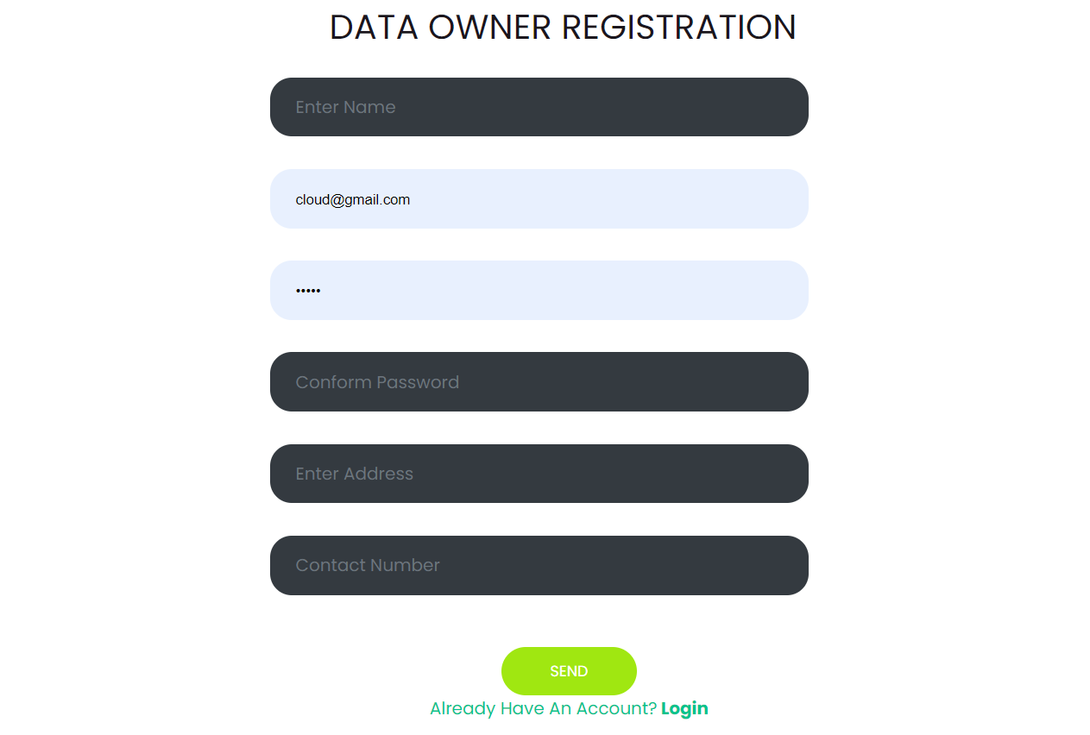

Login: The data owner can login with using valid credentials.

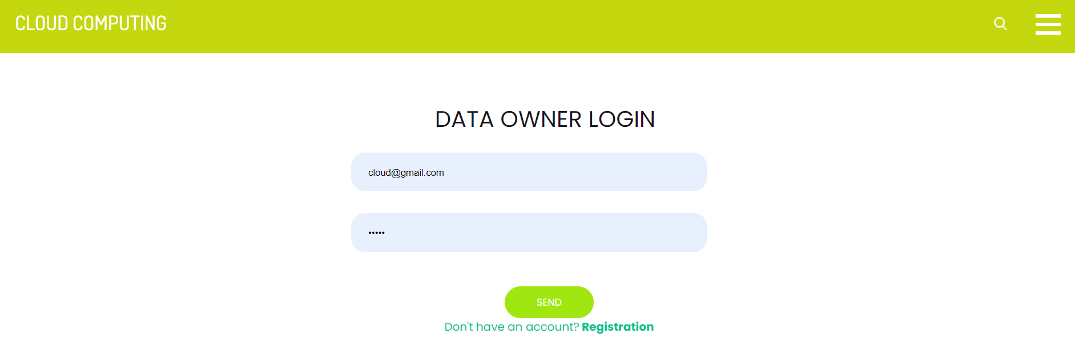

View profile: The data owner can view their profile.

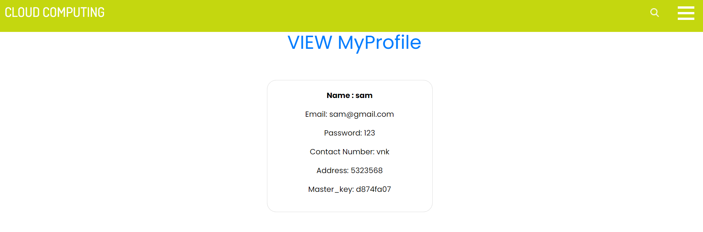
Request key: The data owner needs to request to key authentication for kay access.

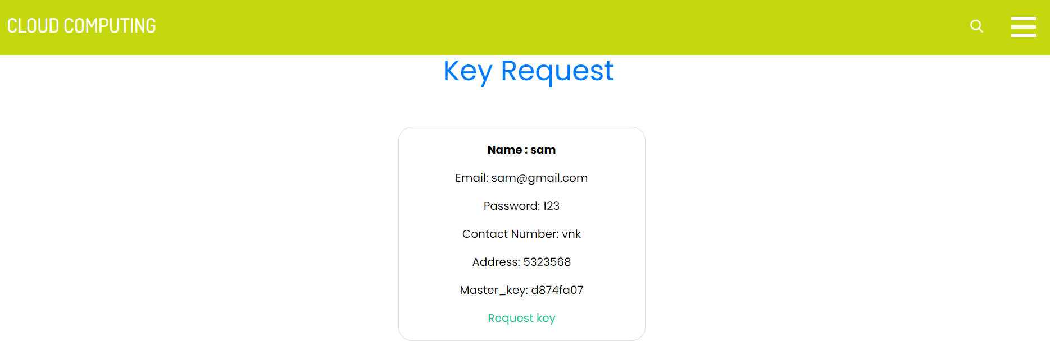
Upload file: The data owner can upload file to cloud with encrypting.

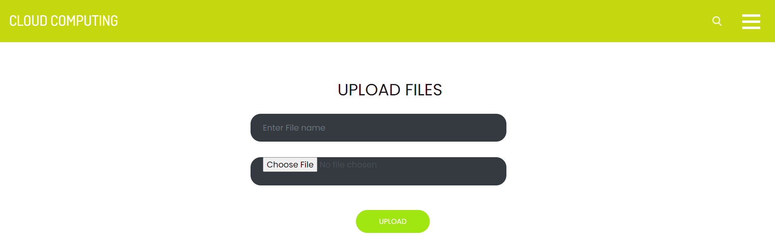

User Modules:

Sign up: The user needs to sign up with using the valid inputs.

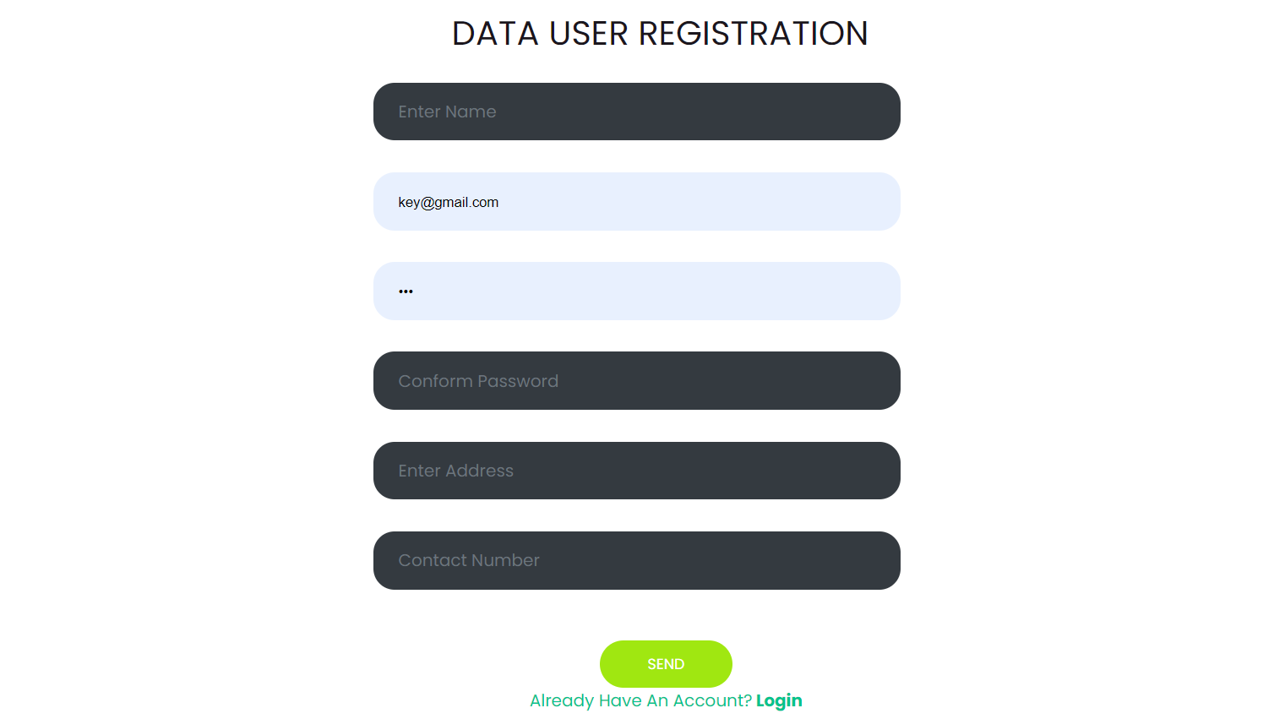

Sign in: The user can login with using valid credentials.

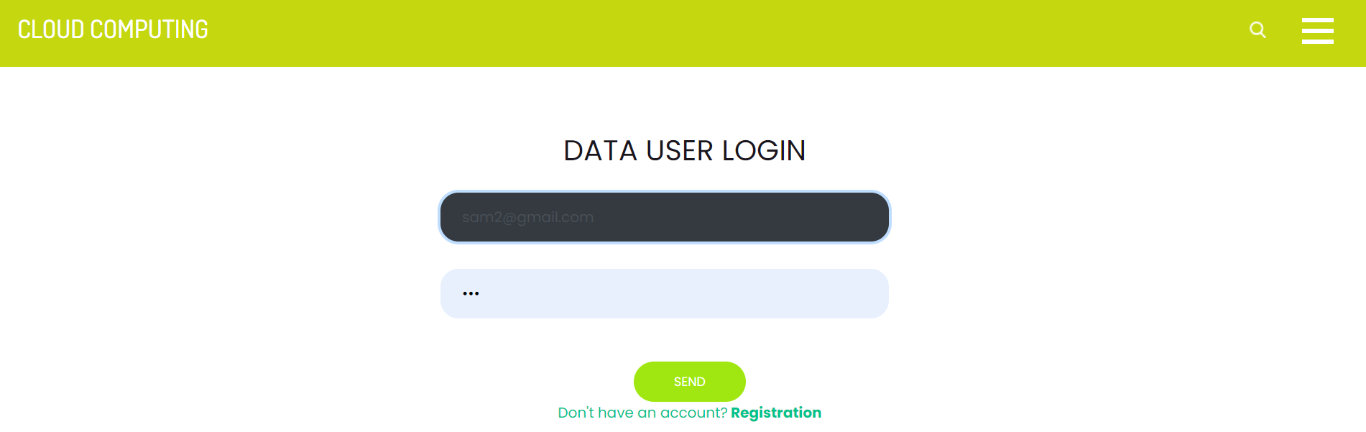
Search file: The user has a option to search files.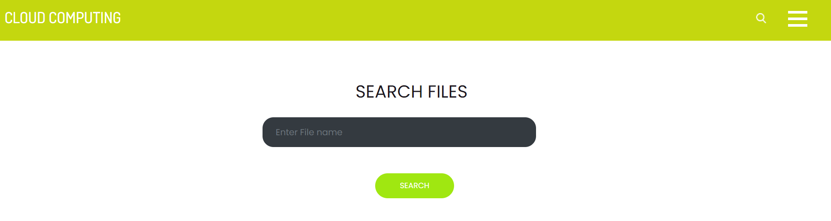

Send file request: The user need to send a file request for file access.

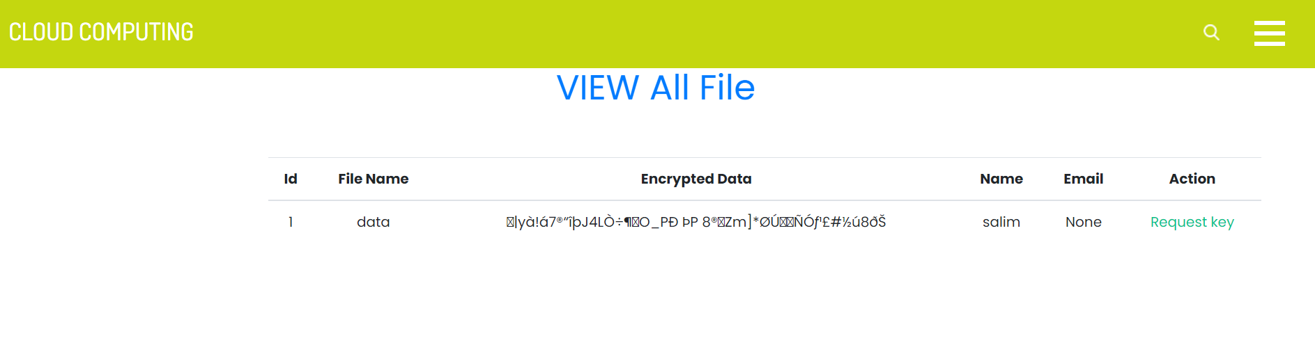

Decrypt& download file: After request approval the user ha a access to download the data.

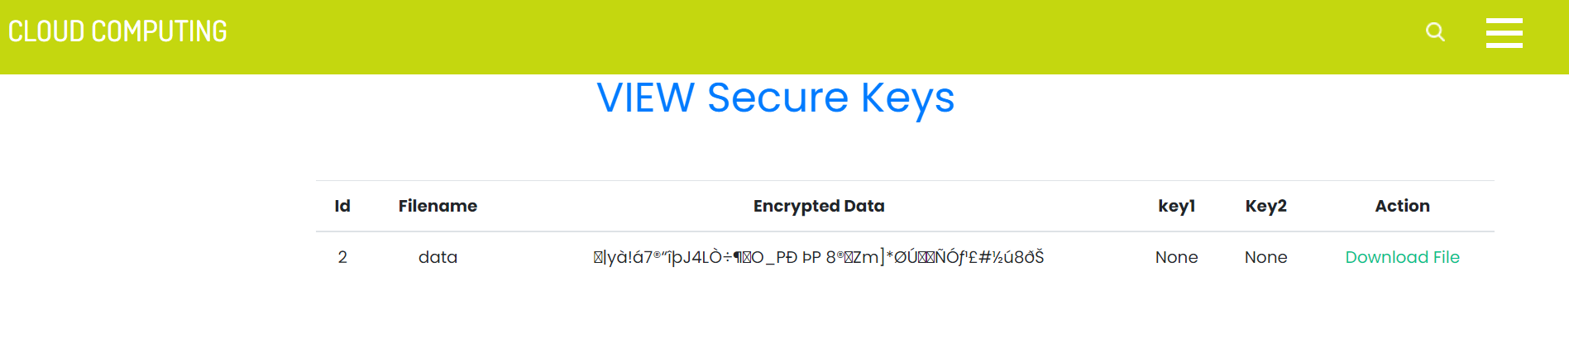

Logout: The users should be logout.

Key Authority Module:

Login: The key authority has default login credentials, authority can login directly.

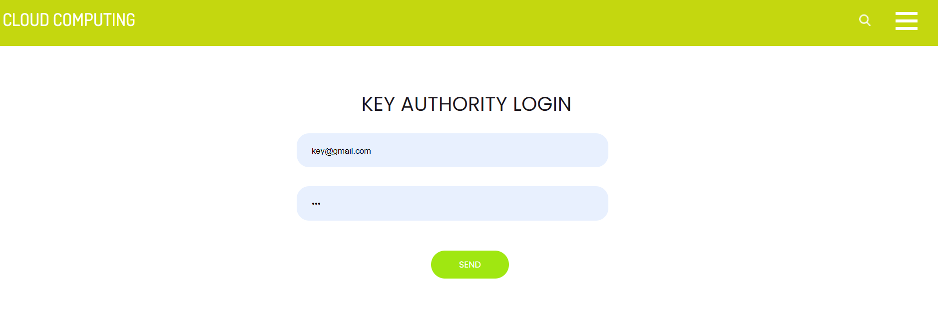

View key request: He can view the all request’s.

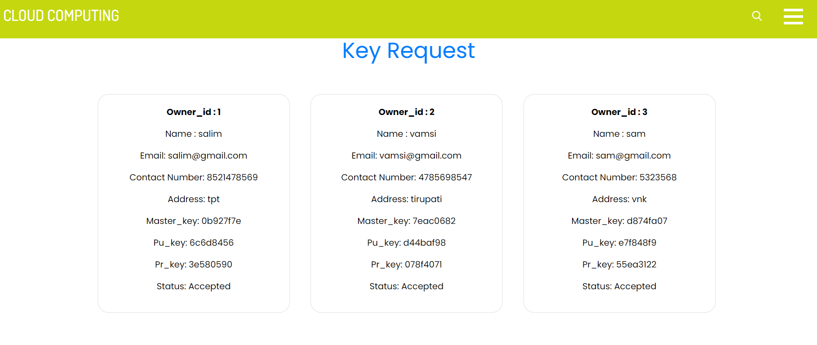

Provide key: The authority can provide the key to particular user.

Logout: The key authority should be logout.

Admin Module:

Login: The key authority has default login credentials, authority can login directly.

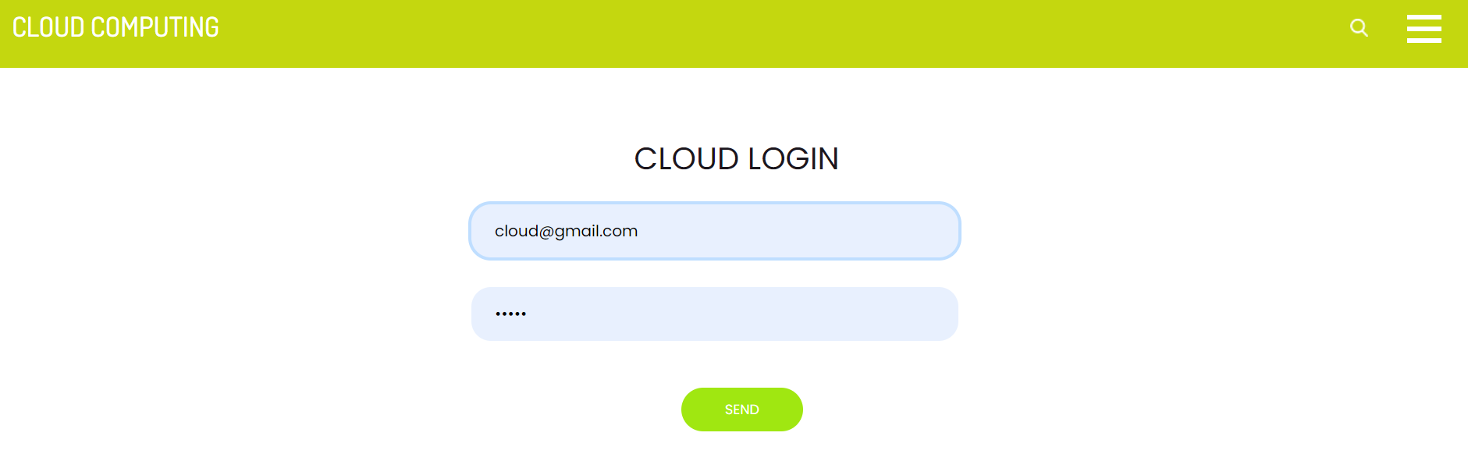

View key request: He can view the all request’s.

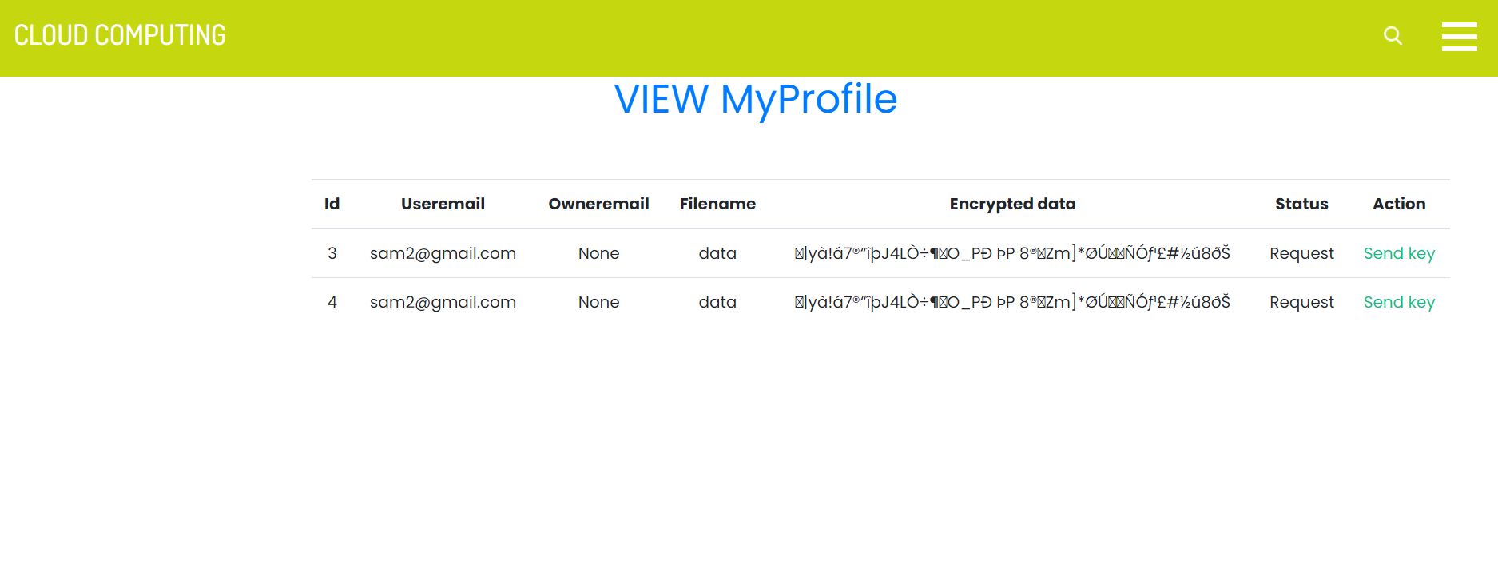
Provide key: The authority can provide the key to particular user.

Logout: The key authority should be logout.

RESULT:

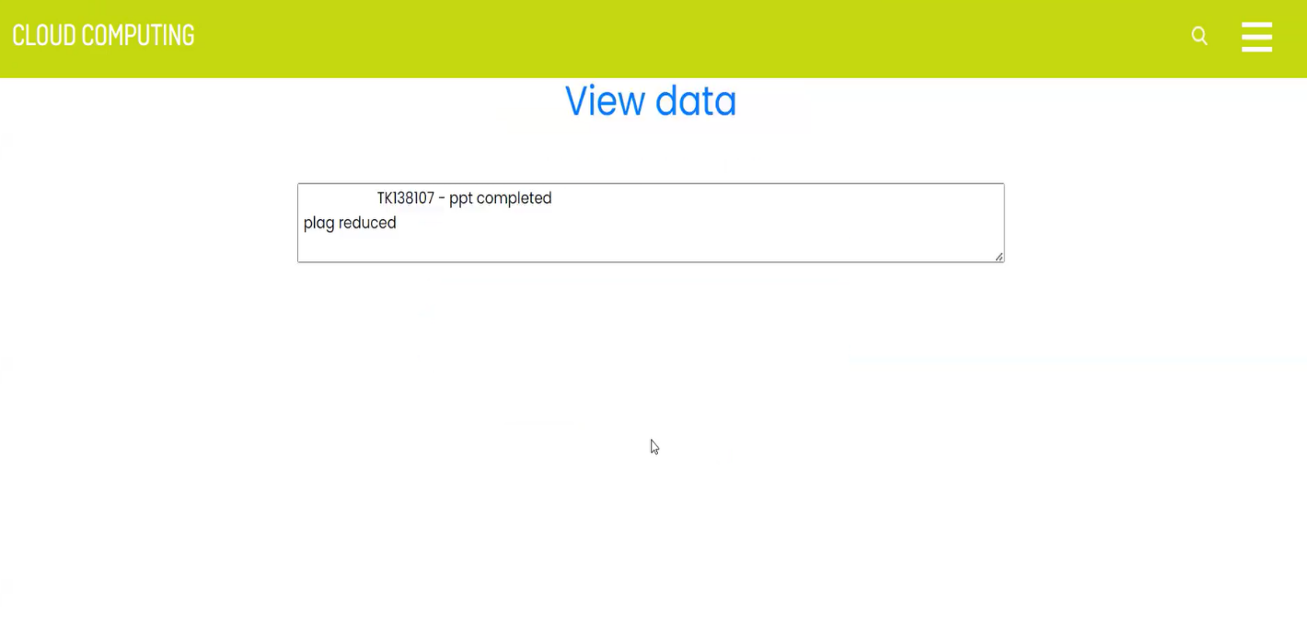

7. SYSTEM STUDY AND TESTING
7.1 Feasibility Study
The feasibility of the project is analysed in this phase and business proposal is put forth with a very general plan for the project and some cost estimates. During system analysis the feasibility study of the proposed system is to be carried out. This is to ensure that the proposed system is not a burden to the company. For feasibility analysis, some understanding of the major requirements for the system is essential.
Three key considerations involved in the feasibility analysis are
- Economical feasibility
- Technical feasibility
- Social feasibility
Economical Feasibility
This study is carried out to check the economic impact that the system will have on the organization. The amount of fund that the company can pour into the research and development of the system is limited. The expenditures must be justified. Thus the developed system as well within the budget and this was achieved because most of the technologies used are freely available. Only the customized products had to be purchased.

Technical Feasibility
This study is carried out to check the technical feasibility, that is, the technical requirements of the system. Any system developed must not have a high demand on the available technical resources. This will lead to high demands on the available technical resources. This will lead to high demands being placed on the client. The developed system must have a modest requirement, as only minimal or null changes are required for implementing this system.
Social Feasibility

The aspect of study is to check the level of acceptance of the system by the user. This includes the process of training the user to use the system efficiently. The user must not feel threatened by the system, instead must accept it as a necessity. The level of acceptance by the users solely depends on the methods that are employed to educate the user about the system and to make him familiar with it. His level of confidence must be raised so that he is also able to make some constructive criticism, which is welcomed, as he is the final user of the system.

System Testing
The purpose of testing is to discover errors. Testing is the process of trying to discover every conceivable fault or weakness in a work product. It provides a way to check the functionality of components, sub-assemblies, assemblies and/or a finished product It is the process of exercising software with the intent of ensuring that the
Software system meets its requirements and user expectations and does not fail in an unacceptable manner. There are various types of test. Each test type addresses a specific testing requirement.

7.2 Types of Tests

7.2.1 Unit testing
Unit testing involves the design of test cases that validate that the internal program logic is functioning properly, and that program inputs produce valid outputs. All decision branches and internal code flow should be validated. It is the testing of individual software units of the application .it is done after the completion of an individual unit before integration. This is a structural testing, that relies on knowledge of its construction and is invasive. Unit tests perform basic tests at component level and test a specific business process, application, and/or system configuration. Unit tests ensure that each unique path of a business process performs accurately to the documented specifications and contains clearly defined inputs and expected results.

7.2.2 Integration testing
Integration tests are designed to test integrated software components to determine if they actually run as one program. Testing is event driven and is more concerned with the basic outcome of screens

or fields. Integration tests demonstrate that although the components were individually satisfaction, as shown by successfully unit testing, the combination of components is correct and consistent. Integration testing is specifically aimed at exposing the problems that arise from the combination of components.
Software integration testing is the incremental integration testing of two or more integrated software components on a single platform to produce failures caused by interface defects.
The task of the integration test is to check that components or software applications, e.g. components in a software system or – one step up – software applications at the company level – interact without error.
Test Results: All the test cases mentioned above passed successfully. No defects encountered.

Acceptance Testing
User Acceptance Testing is a critical phase of any project and requires significant participation by the end user. It also ensures that the system meets the functional requirements.
Test Results: All the test cases mentioned above passed successfully. No defects encountered.

7.2.3 Functional testing
Functional tests provide systematic demonstrations that functions tested are available as specified by the business and technical requirements, system documentation, and user manuals.
Functional testing is centered on the following items:
Valid Input : identified classes of valid input must be accepted.
Invalid Input : identified classes of invalid input must be rejected.
Functions : identified functions must be exercised.
Output : identified classes of application outputs must be exercised.
Systems/Procedures: interfacing systems or procedures must be invoked.

Organization and preparation of functional tests is focused on requirements, key functions, or special test cases. In addition, systematic coverage pertaining to identify Business process flows; data fields, predefined processes, and successive processes must be considered for testing. Before functional testing is complete, additional tests are identified and the effective value of current tests is determined.

7.2.4 White Box Testing
White Box Testing is a testing in which in which the software tester has knowledge of the inner workings, structure and language of the software, or at least its purpose. It is purpose. It is used to test areas that cannot be reached from a black box level.

7.2.5 Black Box Testing
Black Box Testing is testing the software without any knowledge of the inner workings, structure or language of the module being tested. Black box tests, as most other kinds of tests, must be written from a definitive source document, such as specification or requirements document, such as specification or requirements document. It is a testing in which the software under test is treated, as a black box .you cannot “see” into it. The test provides inputs and responds to outputs without considering how the software works.
Test objectives
- All field entries must work properly.
- Pages must be activated from the identified link.
- The entry screen, messages and responses must not be delayed.
Features to be tested
- Verify that the entries are of the correct format
- No duplicate entries should be allowed
- All links should take the user to the correct page.

- TEST CASES:
Input | Output | Result
Input text files | File upload or not | Success

- Test cases Model building:
S.NO | Test cases | I/O | Expected O/T | Actual O/T | P/F
1 | Admin login | Enter email and password | Admin login successful | Admin login successful | P
2 | Upload file | Select file | File uploaded successful | File uploaded successful | P

8.CONCLUSION:

The proposed solution effectively addresses security concerns in CNN-LSTM gesture classification (CNN-LSTM) for secure sign language recognition. By introducing a two-party model inference protocol, it mitigates the latency problem, enhancing overall security. Additionally, the scheme improves attribute expressiveness through skeletal landmarks, reducing access policy complexity and improving gesture recognition efficiency. These advancements not only lower storage costs and classification complexity but also ensure both security and efficiency in practical cloud applications.

9. FUTURE ENHANCEMENT

Integration of homomorphic classification to further enhance privacy-preserving capabilities while maintaining efficiency. Exploration of blockchain technology for decentralized key management, ensuring enhanced resilience against single points of failure. Investigation into post-quantum secure deep learning primitives to future-proof the system against quantum attacks. =In addition to these core enhancements, we will prioritize seamless integration of these technologies, ensuring minimal disruption to existing workflows while maximizing the benefits of enhanced security and privacy. By collaborating with leading experts and research institutions in the field, we will leverage cutting-edge advancements to inform our implementation strategies, ensuring that our system remains at the forefront of deep learning innovation. Moreover, we will conduct thorough testing and evaluation procedures to validate the effectiveness and efficiency of these enhancements in real-world scenarios, guaranteeing robustness and reliability under diverse operational conditions. Our commitment to continuous improvement and innovation underscores our dedication to providing users with the highest standards of security, privacy, and resilience in an ever-evolving threat landscape. Through these strategic initiatives, we aim to position our system as a trusted cornerstone in the realm of secure data management, empowering individuals and organizations to harness the full potential of data-driven technologies with confidence and peace of mind.

10.REFERANCES

[1] J. Baek, Q. H. Vu, J. K. Liu, X. Huang, and Y. Xiang. A secure sign language translation based framework for big data information management of smart grid. IEEE Transactions on Sign Language Translation, 3(2):233–244, 2015.
[2] A. Balu and K. Kuppusamy. An expressive and provably secure landmark sequence-policy gesture classification. Information Sciences, 276(4):354–362, 2014.
[3] M. Belenkiy, J. Camenisch, M. Chase, M. Kohlweiss, A. Lysyanskaya, and H. Shacham. Randomizable proofs and delegatable anonymous credentials. Proceedings of the 29th Annual International Cryptology Conference, pages 108–125, 2009.
[4] J. Bethencourt, A. Sahai, and B. Waters. Landmark Sequence-policy attributebased classification. IEEE Symposium on Security and Privacy, pages 321–334, 2007.
[5] D. Boneh, B. Lynn, and H. Shacham. Short signatures from the weil pairing. Journal of Cryptology, 17(4):297–319, 2001.
[6] M. Chase. Multi-authority attribute based classification. Proceedings of the 4th Conference on Theory of Cryptography, pages 515–534, 2007.
[7] M. Chase and S. S. Chow. Improving privacy and security in multiauthority gesture classification. Proceedings of the 16th ACM Conference on Computer and Communications Security, pages 121–130, 2009.
[8] L. Cheung and C. Newport. Provably secure landmark sequence policy ABE. Proceedings of the 14th ACM conference on Computer and communications security, pages 456–465, 2007.
[9] S. S. Chow. Removing escrow from identity-based classification. Proceedings of the 12th International Conference on Practice and Theory in Public Key Cryptography, pages 256–276, 2009.
[10] C. K. Chu, W. T. Zhu, J. Han, J. K. Liu, J. Xu, and J. Zhou. Security concerns in popular cloud storage services. IEEE Pervasive Computing, 12(4):50–57, 2013.

